Visualisasi data dengan Eksplorasi data analisis

Tentang Data

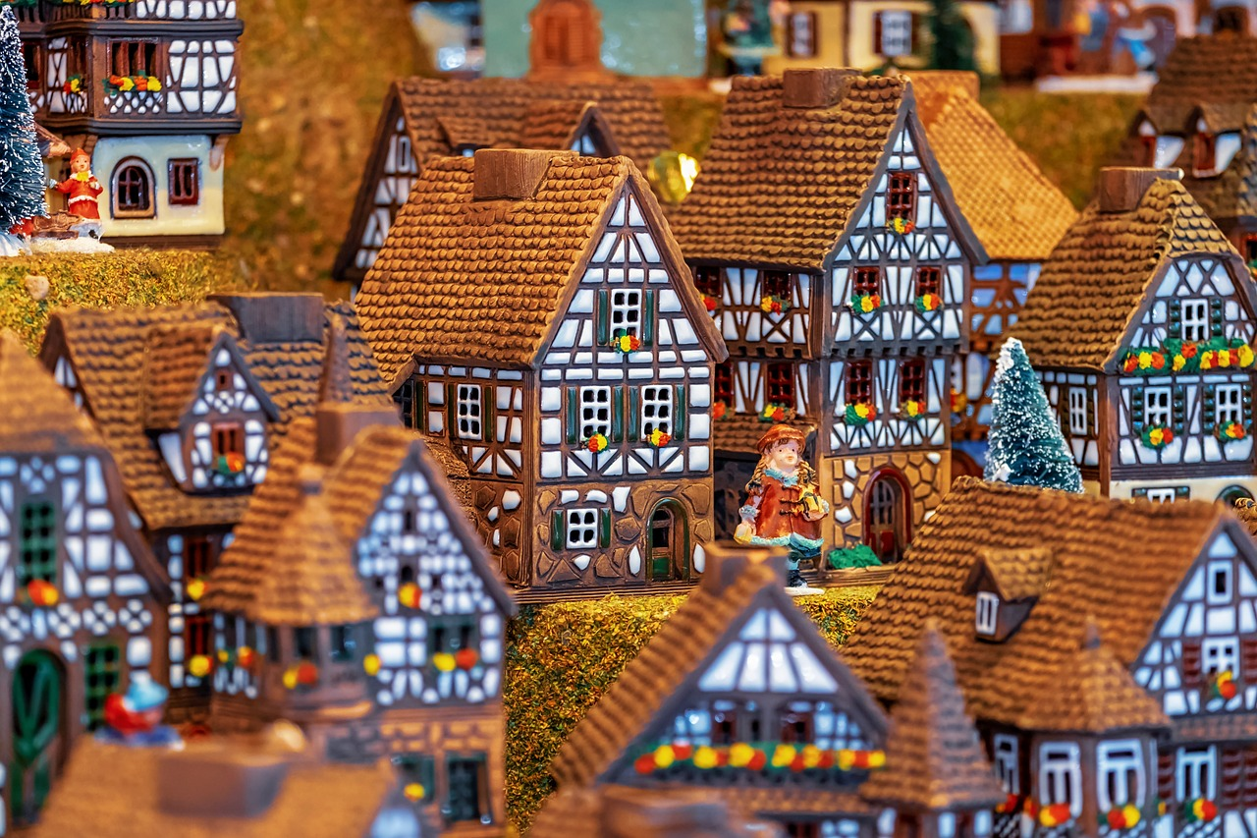

Ask a home buyer to describe their dream house, and they probably won’t begin with the height of the basement ceiling or the proximity to an east-west railroad. But this playground competition’s dataset proves that much more influences price negotiations than the number of bedrooms or a white-picket fence.

With 79 explanatory variables describing (almost) every aspect of residential homes in Ames, Iowa, this competition challenges you to predict the final price of each home.

Deskripsi Setiap Kolom dapat dapat diakses pada link berikut ini

[Deskripsi Data](http://jse.amstat.org/v19n3/decock/DataDocumentation.txt)

Data ini bisa diperoleh di link berikut ini

[Download Data](https://drive.google.com/drive/u/2/folders/1TNlpMfcAWHOY2RcUWutMZ4QXgr5NKv8b)

Package

Silahkan install jika belum ada

install.packages("tidyverse")  
install.packages("DataExplorer")  
install.packages("skimr")

Memanggil Package

library(tidyverse)  
library(DataExplorer)  
library(skimr)

Import Data

data_house <- read.csv("house_price1.csv",stringsAsFactors = TRUE)  
glimpse(data_house)

## Rows: 1,460  
## Columns: 81  
## $ Id <int> 1, 2, 3, 4, 5, 6, 7, 8, 9, 10, 11, 12, 13, 14, 15, 16, 1…  
## $ MSSubClass <int> 60, 20, 60, 70, 60, 50, 20, 60, 50, 190, 20, 60, 20, 20,…  
## $ MSZoning <fct> RL, RL, RL, RL, RL, RL, RL, RL, RM, RL, RL, RL, RL, RL, …  
## $ LotFrontage <int> 65, 80, 68, 60, 84, 85, 75, NA, 51, 50, 70, 85, NA, 91, …  
## $ LotArea <int> 8450, 9600, 11250, 9550, 14260, 14115, 10084, 10382, 612…  
## $ Street <fct> Pave, Pave, Pave, Pave, Pave, Pave, Pave, Pave, Pave, Pa…  
## $ Alley <fct> NA, NA, NA, NA, NA, NA, NA, NA, NA, NA, NA, NA, NA, NA, …  
## $ LotShape <fct> Reg, Reg, IR1, IR1, IR1, IR1, Reg, IR1, Reg, Reg, Reg, I…  
## $ LandContour <fct> Lvl, Lvl, Lvl, Lvl, Lvl, Lvl, Lvl, Lvl, Lvl, Lvl, Lvl, L…  
## $ Utilities <fct> AllPub, AllPub, AllPub, AllPub, AllPub, AllPub, AllPub, …  
## $ LotConfig <fct> Inside, FR2, Inside, Corner, FR2, Inside, Inside, Corner…  
## $ LandSlope <fct> Gtl, Gtl, Gtl, Gtl, Gtl, Gtl, Gtl, Gtl, Gtl, Gtl, Gtl, G…  
## $ Neighborhood <fct> CollgCr, Veenker, CollgCr, Crawfor, NoRidge, Mitchel, So…  
## $ Condition1 <fct> Norm, Feedr, Norm, Norm, Norm, Norm, Norm, PosN, Artery,…  
## $ Condition2 <fct> Norm, Norm, Norm, Norm, Norm, Norm, Norm, Norm, Norm, Ar…  
## $ BldgType <fct> 1Fam, 1Fam, 1Fam, 1Fam, 1Fam, 1Fam, 1Fam, 1Fam, 1Fam, 2f…  
## $ HouseStyle <fct> 2Story, 1Story, 2Story, 2Story, 2Story, 1.5Fin, 1Story, …  
## $ OverallQual <int> 7, 6, 7, 7, 8, 5, 8, 7, 7, 5, 5, 9, 5, 7, 6, 7, 6, 4, 5,…  
## $ OverallCond <int> 5, 8, 5, 5, 5, 5, 5, 6, 5, 6, 5, 5, 6, 5, 5, 8, 7, 5, 5,…  
## $ YearBuilt <int> 2003, 1976, 2001, 1915, 2000, 1993, 2004, 1973, 1931, 19…  
## $ YearRemodAdd <int> 2003, 1976, 2002, 1970, 2000, 1995, 2005, 1973, 1950, 19…  
## $ RoofStyle <fct> Gable, Gable, Gable, Gable, Gable, Gable, Gable, Gable, …  
## $ RoofMatl <fct> CompShg, CompShg, CompShg, CompShg, CompShg, CompShg, Co…  
## $ Exterior1st <fct> VinylSd, MetalSd, VinylSd, Wd Sdng, VinylSd, VinylSd, Vi…  
## $ Exterior2nd <fct> VinylSd, MetalSd, VinylSd, Wd Shng, VinylSd, VinylSd, Vi…  
## $ MasVnrType <fct> BrkFace, None, BrkFace, None, BrkFace, None, Stone, Ston…  
## $ MasVnrArea <int> 196, 0, 162, 0, 350, 0, 186, 240, 0, 0, 0, 286, 0, 306, …  
## $ ExterQual <fct> Gd, TA, Gd, TA, Gd, TA, Gd, TA, TA, TA, TA, Ex, TA, Gd, …  
## $ ExterCond <fct> TA, TA, TA, TA, TA, TA, TA, TA, TA, TA, TA, TA, TA, TA, …  
## $ Foundation <fct> PConc, CBlock, PConc, BrkTil, PConc, Wood, PConc, CBlock…  
## $ BsmtQual <fct> Gd, Gd, Gd, TA, Gd, Gd, Ex, Gd, TA, TA, TA, Ex, TA, Gd, …  
## $ BsmtCond <fct> TA, TA, TA, Gd, TA, TA, TA, TA, TA, TA, TA, TA, TA, TA, …  
## $ BsmtExposure <fct> No, Gd, Mn, No, Av, No, Av, Mn, No, No, No, No, No, Av, …  
## $ BsmtFinType1 <fct> GLQ, ALQ, GLQ, ALQ, GLQ, GLQ, GLQ, ALQ, Unf, GLQ, Rec, G…  
## $ BsmtFinSF1 <int> 706, 978, 486, 216, 655, 732, 1369, 859, 0, 851, 906, 99…  
## $ BsmtFinType2 <fct> Unf, Unf, Unf, Unf, Unf, Unf, Unf, BLQ, Unf, Unf, Unf, U…  
## $ BsmtFinSF2 <int> 0, 0, 0, 0, 0, 0, 0, 32, 0, 0, 0, 0, 0, 0, 0, 0, 0, 0, 0…  
## $ BsmtUnfSF <int> 150, 284, 434, 540, 490, 64, 317, 216, 952, 140, 134, 17…  
## $ TotalBsmtSF <int> 856, 1262, 920, 756, 1145, 796, 1686, 1107, 952, 991, 10…  
## $ Heating <fct> GasA, GasA, GasA, GasA, GasA, GasA, GasA, GasA, GasA, Ga…  
## $ HeatingQC <fct> Ex, Ex, Ex, Gd, Ex, Ex, Ex, Ex, Gd, Ex, Ex, Ex, TA, Ex, …  
## $ CentralAir <fct> Y, Y, Y, Y, Y, Y, Y, Y, Y, Y, Y, Y, Y, Y, Y, Y, Y, Y, Y,…  
## $ Electrical <fct> SBrkr, SBrkr, SBrkr, SBrkr, SBrkr, SBrkr, SBrkr, SBrkr, …  
## $ X1stFlrSF <int> 856, 1262, 920, 961, 1145, 796, 1694, 1107, 1022, 1077, …  
## $ X2ndFlrSF <int> 854, 0, 866, 756, 1053, 566, 0, 983, 752, 0, 0, 1142, 0,…  
## $ LowQualFinSF <int> 0, 0, 0, 0, 0, 0, 0, 0, 0, 0, 0, 0, 0, 0, 0, 0, 0, 0, 0,…  
## $ GrLivArea <int> 1710, 1262, 1786, 1717, 2198, 1362, 1694, 2090, 1774, 10…  
## $ BsmtFullBath <int> 1, 0, 1, 1, 1, 1, 1, 1, 0, 1, 1, 1, 1, 0, 1, 0, 1, 0, 1,…  
## $ BsmtHalfBath <int> 0, 1, 0, 0, 0, 0, 0, 0, 0, 0, 0, 0, 0, 0, 0, 0, 0, 0, 0,…  
## $ FullBath <int> 2, 2, 2, 1, 2, 1, 2, 2, 2, 1, 1, 3, 1, 2, 1, 1, 1, 2, 1,…  
## $ HalfBath <int> 1, 0, 1, 0, 1, 1, 0, 1, 0, 0, 0, 0, 0, 0, 1, 0, 0, 0, 1,…  
## $ BedroomAbvGr <int> 3, 3, 3, 3, 4, 1, 3, 3, 2, 2, 3, 4, 2, 3, 2, 2, 2, 2, 3,…  
## $ KitchenAbvGr <int> 1, 1, 1, 1, 1, 1, 1, 1, 2, 2, 1, 1, 1, 1, 1, 1, 1, 2, 1,…  
## $ KitchenQual <fct> Gd, TA, Gd, Gd, Gd, TA, Gd, TA, TA, TA, TA, Ex, TA, Gd, …  
## $ TotRmsAbvGrd <int> 8, 6, 6, 7, 9, 5, 7, 7, 8, 5, 5, 11, 4, 7, 5, 5, 5, 6, 6…  
## $ Functional <fct> Typ, Typ, Typ, Typ, Typ, Typ, Typ, Typ, Min1, Typ, Typ, …  
## $ Fireplaces <int> 0, 1, 1, 1, 1, 0, 1, 2, 2, 2, 0, 2, 0, 1, 1, 0, 1, 0, 0,…  
## $ FireplaceQu <fct> NA, TA, TA, Gd, TA, NA, Gd, TA, TA, TA, NA, Gd, NA, Gd, …  
## $ GarageType <fct> Attchd, Attchd, Attchd, Detchd, Attchd, Attchd, Attchd, …  
## $ GarageYrBlt <int> 2003, 1976, 2001, 1998, 2000, 1993, 2004, 1973, 1931, 19…  
## $ GarageFinish <fct> RFn, RFn, RFn, Unf, RFn, Unf, RFn, RFn, Unf, RFn, Unf, F…  
## $ GarageCars <int> 2, 2, 2, 3, 3, 2, 2, 2, 2, 1, 1, 3, 1, 3, 1, 2, 2, 2, 2,…  
## $ GarageArea <int> 548, 460, 608, 642, 836, 480, 636, 484, 468, 205, 384, 7…  
## $ GarageQual <fct> TA, TA, TA, TA, TA, TA, TA, TA, Fa, Gd, TA, TA, TA, TA, …  
## $ GarageCond <fct> TA, TA, TA, TA, TA, TA, TA, TA, TA, TA, TA, TA, TA, TA, …  
## $ PavedDrive <fct> Y, Y, Y, Y, Y, Y, Y, Y, Y, Y, Y, Y, Y, Y, Y, Y, Y, Y, Y,…  
## $ WoodDeckSF <int> 0, 298, 0, 0, 192, 40, 255, 235, 90, 0, 0, 147, 140, 160…  
## $ OpenPorchSF <int> 61, 0, 42, 35, 84, 30, 57, 204, 0, 4, 0, 21, 0, 33, 213,…  
## $ EnclosedPorch <int> 0, 0, 0, 272, 0, 0, 0, 228, 205, 0, 0, 0, 0, 0, 176, 0, …  
## $ X3SsnPorch <int> 0, 0, 0, 0, 0, 320, 0, 0, 0, 0, 0, 0, 0, 0, 0, 0, 0, 0, …  
## $ ScreenPorch <int> 0, 0, 0, 0, 0, 0, 0, 0, 0, 0, 0, 0, 176, 0, 0, 0, 0, 0, …  
## $ PoolArea <int> 0, 0, 0, 0, 0, 0, 0, 0, 0, 0, 0, 0, 0, 0, 0, 0, 0, 0, 0,…  
## $ PoolQC <fct> NA, NA, NA, NA, NA, NA, NA, NA, NA, NA, NA, NA, NA, NA, …  
## $ Fence <fct> NA, NA, NA, NA, NA, MnPrv, NA, NA, NA, NA, NA, NA, NA, N…  
## $ MiscFeature <fct> NA, NA, NA, NA, NA, Shed, NA, Shed, NA, NA, NA, NA, NA, …  
## $ MiscVal <int> 0, 0, 0, 0, 0, 700, 0, 350, 0, 0, 0, 0, 0, 0, 0, 0, 700,…  
## $ MoSold <int> 2, 5, 9, 2, 12, 10, 8, 11, 4, 1, 2, 7, 9, 8, 5, 7, 3, 10…  
## $ YrSold <int> 2008, 2007, 2008, 2006, 2008, 2009, 2007, 2009, 2008, 20…  
## $ SaleType <fct> WD, WD, WD, WD, WD, WD, WD, WD, WD, WD, WD, New, WD, New…  
## $ SaleCondition <fct> Normal, Normal, Normal, Abnorml, Normal, Normal, Normal,…  
## $ SalePrice <int> 208500, 181500, 223500, 140000, 250000, 143000, 307000, …

Memeriksa Gambaran Umum Data

plot_intro(data = data_house,  
 geom_label_args = list(size=2.5))

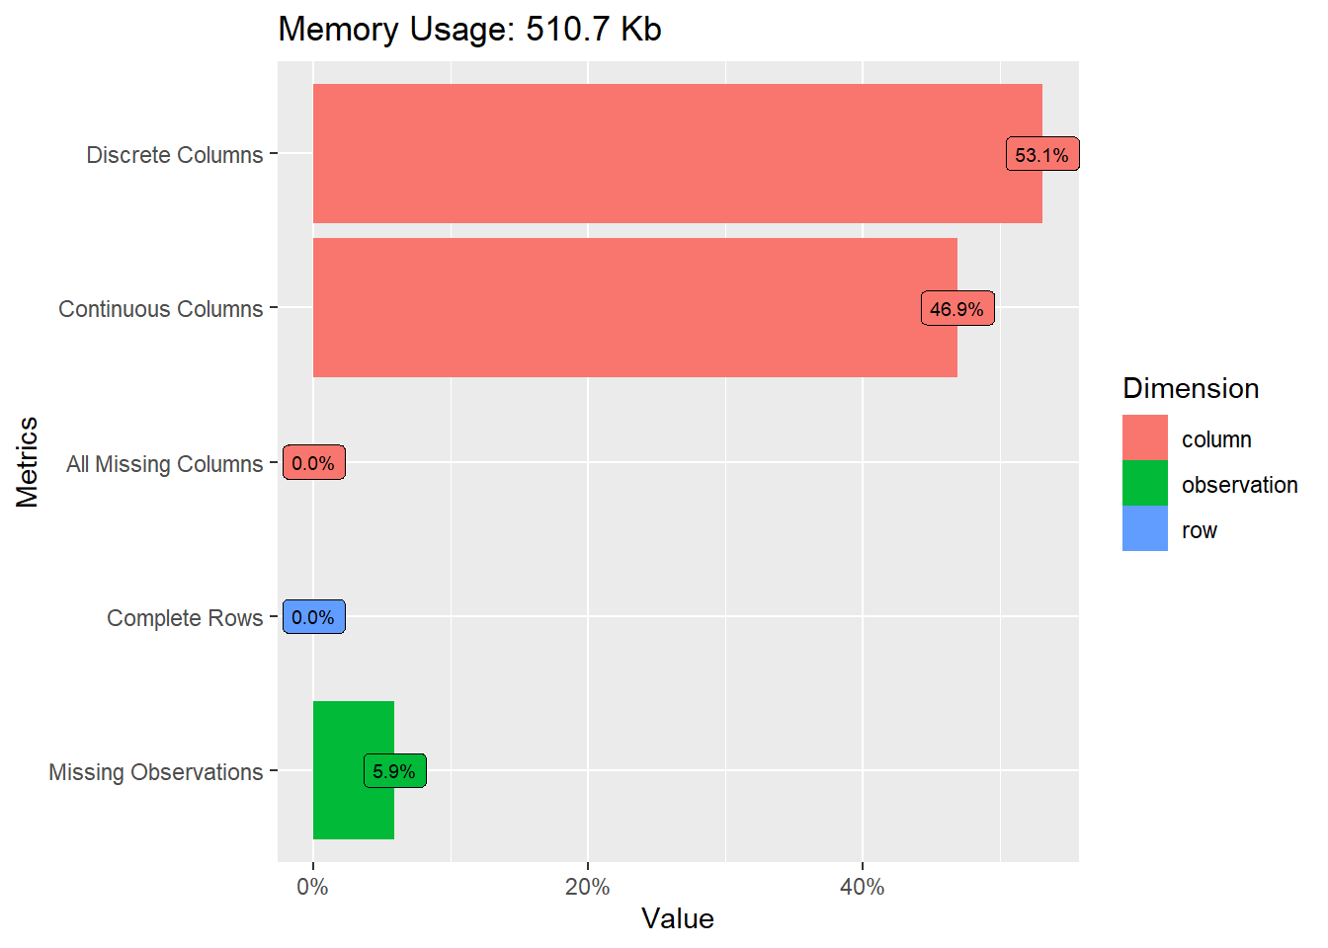 Catatan:

* plot_intro merupakan fungsi yang berasal dari package DataExplorer dan argumen utamanya adalah object berbentuk data.frame.
* argumen geom_label_args bisa diisi dengan opsi-opsi yang ada pada fungsi geom_label pada pacakge ggplot2.

skim_without_charts(data = data_house)

Data summary

| Name | data_house |
| --- | --- |
| Number of rows | 1460 |
| Number of columns | 81 |
| _______________________ |  |
| Column type frequency: |  |
| factor | 43 |
| numeric | 38 |
| ________________________ |  |
| Group variables | None |

Variable type: factor

| skim_variable | n_missing | complete_rate | ordered | n_unique | top_counts |
| --- | --- | --- | --- | --- | --- |
| MSZoning | 0 | 1.00 | FALSE | 5 | RL: 1151, RM: 218, FV: 65, RH: 16 |
| Street | 0 | 1.00 | FALSE | 2 | Pav: 1454, Grv: 6 |
| Alley | 1369 | 0.06 | FALSE | 2 | Grv: 50, Pav: 41 |
| LotShape | 0 | 1.00 | FALSE | 4 | Reg: 925, IR1: 484, IR2: 41, IR3: 10 |
| LandContour | 0 | 1.00 | FALSE | 4 | Lvl: 1311, Bnk: 63, HLS: 50, Low: 36 |
| Utilities | 0 | 1.00 | FALSE | 2 | All: 1459, NoS: 1 |
| LotConfig | 0 | 1.00 | FALSE | 5 | Ins: 1052, Cor: 263, Cul: 94, FR2: 47 |
| LandSlope | 0 | 1.00 | FALSE | 3 | Gtl: 1382, Mod: 65, Sev: 13 |
| Neighborhood | 0 | 1.00 | FALSE | 25 | NAm: 225, Col: 150, Old: 113, Edw: 100 |
| Condition1 | 0 | 1.00 | FALSE | 9 | Nor: 1260, Fee: 81, Art: 48, RRA: 26 |
| Condition2 | 0 | 1.00 | FALSE | 8 | Nor: 1445, Fee: 6, Art: 2, Pos: 2 |
| BldgType | 0 | 1.00 | FALSE | 5 | 1Fa: 1220, Twn: 114, Dup: 52, Twn: 43 |
| HouseStyle | 0 | 1.00 | FALSE | 8 | 1St: 726, 2St: 445, 1.5: 154, SLv: 65 |
| RoofStyle | 0 | 1.00 | FALSE | 6 | Gab: 1141, Hip: 286, Fla: 13, Gam: 11 |
| RoofMatl | 0 | 1.00 | FALSE | 8 | Com: 1434, Tar: 11, WdS: 6, WdS: 5 |
| Exterior1st | 0 | 1.00 | FALSE | 15 | Vin: 515, HdB: 222, Met: 220, Wd : 206 |
| Exterior2nd | 0 | 1.00 | FALSE | 16 | Vin: 504, Met: 214, HdB: 207, Wd : 197 |
| MasVnrType | 8 | 0.99 | FALSE | 4 | Non: 864, Brk: 445, Sto: 128, Brk: 15 |
| ExterQual | 0 | 1.00 | FALSE | 4 | TA: 906, Gd: 488, Ex: 52, Fa: 14 |
| ExterCond | 0 | 1.00 | FALSE | 5 | TA: 1282, Gd: 146, Fa: 28, Ex: 3 |
| Foundation | 0 | 1.00 | FALSE | 6 | PCo: 647, CBl: 634, Brk: 146, Sla: 24 |
| BsmtQual | 37 | 0.97 | FALSE | 4 | TA: 649, Gd: 618, Ex: 121, Fa: 35 |
| BsmtCond | 37 | 0.97 | FALSE | 4 | TA: 1311, Gd: 65, Fa: 45, Po: 2 |
| BsmtExposure | 38 | 0.97 | FALSE | 4 | No: 953, Av: 221, Gd: 134, Mn: 114 |
| BsmtFinType1 | 37 | 0.97 | FALSE | 6 | Unf: 430, GLQ: 418, ALQ: 220, BLQ: 148 |
| BsmtFinType2 | 38 | 0.97 | FALSE | 6 | Unf: 1256, Rec: 54, LwQ: 46, BLQ: 33 |
| Heating | 0 | 1.00 | FALSE | 6 | Gas: 1428, Gas: 18, Gra: 7, Wal: 4 |
| HeatingQC | 0 | 1.00 | FALSE | 5 | Ex: 741, TA: 428, Gd: 241, Fa: 49 |
| CentralAir | 0 | 1.00 | FALSE | 2 | Y: 1365, N: 95 |
| Electrical | 1 | 1.00 | FALSE | 5 | SBr: 1334, Fus: 94, Fus: 27, Fus: 3 |
| KitchenQual | 0 | 1.00 | FALSE | 4 | TA: 735, Gd: 586, Ex: 100, Fa: 39 |
| Functional | 0 | 1.00 | FALSE | 7 | Typ: 1360, Min: 34, Min: 31, Mod: 15 |
| FireplaceQu | 690 | 0.53 | FALSE | 5 | Gd: 380, TA: 313, Fa: 33, Ex: 24 |
| GarageType | 81 | 0.94 | FALSE | 6 | Att: 870, Det: 387, Bui: 88, Bas: 19 |
| GarageFinish | 81 | 0.94 | FALSE | 3 | Unf: 605, RFn: 422, Fin: 352 |
| GarageQual | 81 | 0.94 | FALSE | 5 | TA: 1311, Fa: 48, Gd: 14, Ex: 3 |
| GarageCond | 81 | 0.94 | FALSE | 5 | TA: 1326, Fa: 35, Gd: 9, Po: 7 |
| PavedDrive | 0 | 1.00 | FALSE | 3 | Y: 1340, N: 90, P: 30 |
| PoolQC | 1453 | 0.00 | FALSE | 3 | Gd: 3, Ex: 2, Fa: 2 |
| Fence | 1179 | 0.19 | FALSE | 4 | MnP: 157, GdP: 59, GdW: 54, MnW: 11 |
| MiscFeature | 1406 | 0.04 | FALSE | 4 | She: 49, Gar: 2, Oth: 2, Ten: 1 |
| SaleType | 0 | 1.00 | FALSE | 9 | WD: 1267, New: 122, COD: 43, Con: 9 |
| SaleCondition | 0 | 1.00 | FALSE | 6 | Nor: 1198, Par: 125, Abn: 101, Fam: 20 |

Variable type: numeric

| skim_variable | n_missing | complete_rate | mean | sd | p0 | p25 | p50 | p75 | p100 |
| --- | --- | --- | --- | --- | --- | --- | --- | --- | --- |
| Id | 0 | 1.00 | 730.50 | 421.61 | 1 | 365.75 | 730.5 | 1095.25 | 1460 |
| MSSubClass | 0 | 1.00 | 56.90 | 42.30 | 20 | 20.00 | 50.0 | 70.00 | 190 |
| LotFrontage | 259 | 0.82 | 70.05 | 24.28 | 21 | 59.00 | 69.0 | 80.00 | 313 |
| LotArea | 0 | 1.00 | 10516.83 | 9981.26 | 1300 | 7553.50 | 9478.5 | 11601.50 | 215245 |
| OverallQual | 0 | 1.00 | 6.10 | 1.38 | 1 | 5.00 | 6.0 | 7.00 | 10 |
| OverallCond | 0 | 1.00 | 5.58 | 1.11 | 1 | 5.00 | 5.0 | 6.00 | 9 |
| YearBuilt | 0 | 1.00 | 1971.27 | 30.20 | 1872 | 1954.00 | 1973.0 | 2000.00 | 2010 |
| YearRemodAdd | 0 | 1.00 | 1984.87 | 20.65 | 1950 | 1967.00 | 1994.0 | 2004.00 | 2010 |
| MasVnrArea | 8 | 0.99 | 103.69 | 181.07 | 0 | 0.00 | 0.0 | 166.00 | 1600 |
| BsmtFinSF1 | 0 | 1.00 | 443.64 | 456.10 | 0 | 0.00 | 383.5 | 712.25 | 5644 |
| BsmtFinSF2 | 0 | 1.00 | 46.55 | 161.32 | 0 | 0.00 | 0.0 | 0.00 | 1474 |
| BsmtUnfSF | 0 | 1.00 | 567.24 | 441.87 | 0 | 223.00 | 477.5 | 808.00 | 2336 |
| TotalBsmtSF | 0 | 1.00 | 1057.43 | 438.71 | 0 | 795.75 | 991.5 | 1298.25 | 6110 |
| X1stFlrSF | 0 | 1.00 | 1162.63 | 386.59 | 334 | 882.00 | 1087.0 | 1391.25 | 4692 |
| X2ndFlrSF | 0 | 1.00 | 346.99 | 436.53 | 0 | 0.00 | 0.0 | 728.00 | 2065 |
| LowQualFinSF | 0 | 1.00 | 5.84 | 48.62 | 0 | 0.00 | 0.0 | 0.00 | 572 |
| GrLivArea | 0 | 1.00 | 1515.46 | 525.48 | 334 | 1129.50 | 1464.0 | 1776.75 | 5642 |
| BsmtFullBath | 0 | 1.00 | 0.43 | 0.52 | 0 | 0.00 | 0.0 | 1.00 | 3 |
| BsmtHalfBath | 0 | 1.00 | 0.06 | 0.24 | 0 | 0.00 | 0.0 | 0.00 | 2 |
| FullBath | 0 | 1.00 | 1.57 | 0.55 | 0 | 1.00 | 2.0 | 2.00 | 3 |
| HalfBath | 0 | 1.00 | 0.38 | 0.50 | 0 | 0.00 | 0.0 | 1.00 | 2 |
| BedroomAbvGr | 0 | 1.00 | 2.87 | 0.82 | 0 | 2.00 | 3.0 | 3.00 | 8 |
| KitchenAbvGr | 0 | 1.00 | 1.05 | 0.22 | 0 | 1.00 | 1.0 | 1.00 | 3 |
| TotRmsAbvGrd | 0 | 1.00 | 6.52 | 1.63 | 2 | 5.00 | 6.0 | 7.00 | 14 |
| Fireplaces | 0 | 1.00 | 0.61 | 0.64 | 0 | 0.00 | 1.0 | 1.00 | 3 |
| GarageYrBlt | 81 | 0.94 | 1978.51 | 24.69 | 1900 | 1961.00 | 1980.0 | 2002.00 | 2010 |
| GarageCars | 0 | 1.00 | 1.77 | 0.75 | 0 | 1.00 | 2.0 | 2.00 | 4 |
| GarageArea | 0 | 1.00 | 472.98 | 213.80 | 0 | 334.50 | 480.0 | 576.00 | 1418 |
| WoodDeckSF | 0 | 1.00 | 94.24 | 125.34 | 0 | 0.00 | 0.0 | 168.00 | 857 |
| OpenPorchSF | 0 | 1.00 | 46.66 | 66.26 | 0 | 0.00 | 25.0 | 68.00 | 547 |
| EnclosedPorch | 0 | 1.00 | 21.95 | 61.12 | 0 | 0.00 | 0.0 | 0.00 | 552 |
| X3SsnPorch | 0 | 1.00 | 3.41 | 29.32 | 0 | 0.00 | 0.0 | 0.00 | 508 |
| ScreenPorch | 0 | 1.00 | 15.06 | 55.76 | 0 | 0.00 | 0.0 | 0.00 | 480 |
| PoolArea | 0 | 1.00 | 2.76 | 40.18 | 0 | 0.00 | 0.0 | 0.00 | 738 |
| MiscVal | 0 | 1.00 | 43.49 | 496.12 | 0 | 0.00 | 0.0 | 0.00 | 15500 |
| MoSold | 0 | 1.00 | 6.32 | 2.70 | 1 | 5.00 | 6.0 | 8.00 | 12 |
| YrSold | 0 | 1.00 | 2007.82 | 1.33 | 2006 | 2007.00 | 2008.0 | 2009.00 | 2010 |
| SalePrice | 0 | 1.00 | 180921.20 | 79442.50 | 34900 | 129975.00 | 163000.0 | 214000.00 | 755000 |

Catatan:

* skim_without_charts merupakan fungsi yang berasal dari package skimr dan argumen utamanya adalah object berbentuk data.frame.

Berdasarkan informasi diatas, kita tahu terdata beberapa kolom yang memiliki missing value. Namun hanya 5 kolom saja yang mengalami banyak missing value yaitu Alley,FireplaceQu,PoolQX,Fence,MiscFeature.

Menangani Missing Value

Dalam kasus ini kita akan menangani missing value dengan dua cara, yaitu

1. Mereplace missing value pada kolom-kolom yang memiliki banyak sekali missing value (diatas 500)
2. Menghapus baris-baris yang mengandung missing value pada kolom-kolom yang memiliki sedikti missing value (dibawah 500)

Berikut dibawah ini adalah sintaks untuk melakukan replace missing value, khususnya jika datanya berupa factor atau string. Kemudian na.omit digunakan untuk menghapus semua baris yang mengandung missing value

data_house1 <- data_house %>%  
 select(-Id) %>%   
 mutate(  
 Alley = forcats::fct_explicit_na(Alley, na_level = "Ukn"),  
 FireplaceQu=forcats::fct_explicit_na(FireplaceQu,  
 na_level = "Ukn"   
 ),  
 PoolQC = forcats::fct_explicit_na(PoolQC, na_level = "Ukn"),  
 Fence = forcats::fct_explicit_na(Fence, na_level = "Ukn"),  
 MiscFeature = forcats::fct_explicit_na(MiscFeature, na_level = "Ukn")  
 ) %>% na.omit

## Warning: There was 1 warning in `mutate()`.  
## ℹ In argument: `Alley = forcats::fct_explicit_na(Alley, na_level = "Ukn")`.  
## Caused by warning:  
## ! `fct_explicit_na()` was deprecated in forcats 1.0.0.  
## ℹ Please use `fct_na_value_to_level()` instead.

Kemudian kita akan lihat kembali data yang sudah kita tangani missing valuenya

plot_intro(data = data_house1)

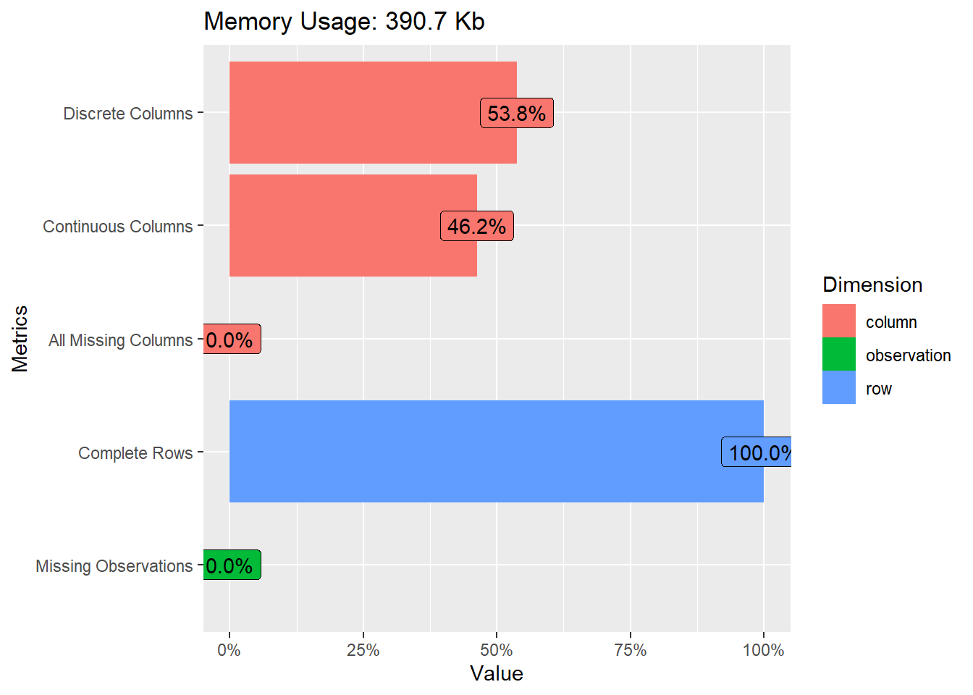

skim_without_charts(data_house1)

Data summary

| Name | data_house1 |
| --- | --- |
| Number of rows | 1094 |
| Number of columns | 80 |
| _______________________ |  |
| Column type frequency: |  |
| factor | 43 |
| numeric | 37 |
| ________________________ |  |
| Group variables | None |

Variable type: factor

| skim_variable | n_missing | complete_rate | ordered | n_unique | top_counts |
| --- | --- | --- | --- | --- | --- |
| MSZoning | 0 | 1 | FALSE | 5 | RL: 850, RM: 173, FV: 54, RH: 9 |
| Street | 0 | 1 | FALSE | 2 | Pav: 1090, Grv: 4 |
| Alley | 0 | 1 | FALSE | 3 | Ukn: 1017, Grv: 41, Pav: 36 |
| LotShape | 0 | 1 | FALSE | 4 | Reg: 760, IR1: 301, IR2: 26, IR3: 7 |
| LandContour | 0 | 1 | FALSE | 4 | Lvl: 991, Bnk: 45, HLS: 44, Low: 14 |
| Utilities | 0 | 1 | FALSE | 1 | All: 1094, NoS: 0 |
| LotConfig | 0 | 1 | FALSE | 5 | Ins: 830, Cor: 187, Cul: 44, FR2: 29 |
| LandSlope | 0 | 1 | FALSE | 3 | Gtl: 1045, Mod: 44, Sev: 5 |
| Neighborhood | 0 | 1 | FALSE | 25 | NAm: 173, Col: 122, Old: 96, Som: 75 |
| Condition1 | 0 | 1 | FALSE | 9 | Nor: 950, Fee: 52, Art: 42, RRA: 24 |
| Condition2 | 0 | 1 | FALSE | 6 | Nor: 1082, Fee: 5, Art: 2, Pos: 2 |
| BldgType | 0 | 1 | FALSE | 5 | 1Fa: 925, Twn: 90, Twn: 35, Dup: 24 |
| HouseStyle | 0 | 1 | FALSE | 8 | 1St: 540, 2St: 346, 1.5: 117, SLv: 43 |
| RoofStyle | 0 | 1 | FALSE | 5 | Gab: 843, Hip: 230, Gam: 10, Man: 6 |
| RoofMatl | 0 | 1 | FALSE | 7 | Com: 1078, WdS: 6, Tar: 5, WdS: 2 |
| Exterior1st | 0 | 1 | FALSE | 14 | Vin: 421, Met: 172, HdB: 151, Wd : 149 |
| Exterior2nd | 0 | 1 | FALSE | 16 | Vin: 412, Met: 169, Wd : 145, HdB: 138 |
| MasVnrType | 0 | 1 | FALSE | 4 | Non: 639, Brk: 327, Sto: 119, Brk: 9 |
| ExterQual | 0 | 1 | FALSE | 4 | TA: 646, Gd: 395, Ex: 46, Fa: 7 |
| ExterCond | 0 | 1 | FALSE | 4 | TA: 973, Gd: 104, Fa: 15, Ex: 2 |
| Foundation | 0 | 1 | FALSE | 5 | PCo: 518, CBl: 446, Brk: 122, Sto: 6 |
| BsmtQual | 0 | 1 | FALSE | 4 | TA: 486, Gd: 463, Ex: 113, Fa: 32 |
| BsmtCond | 0 | 1 | FALSE | 4 | TA: 1006, Gd: 51, Fa: 36, Po: 1 |
| BsmtExposure | 0 | 1 | FALSE | 4 | No: 734, Av: 174, Gd: 97, Mn: 89 |
| BsmtFinType1 | 0 | 1 | FALSE | 6 | Unf: 343, GLQ: 323, ALQ: 162, BLQ: 105 |
| BsmtFinType2 | 0 | 1 | FALSE | 6 | Unf: 972, Rec: 37, LwQ: 35, BLQ: 25 |
| Heating | 0 | 1 | FALSE | 4 | Gas: 1075, Gas: 16, Gra: 2, Oth: 1 |
| HeatingQC | 0 | 1 | FALSE | 5 | Ex: 594, TA: 298, Gd: 174, Fa: 27 |
| CentralAir | 0 | 1 | FALSE | 2 | Y: 1036, N: 58 |
| Electrical | 0 | 1 | FALSE | 5 | SBr: 1009, Fus: 67, Fus: 15, Fus: 2 |
| KitchenQual | 0 | 1 | FALSE | 4 | TA: 528, Gd: 454, Ex: 91, Fa: 21 |
| Functional | 0 | 1 | FALSE | 6 | Typ: 1024, Min: 25, Min: 21, Maj: 10 |
| FireplaceQu | 0 | 1 | FALSE | 6 | Ukn: 511, Gd: 315, TA: 212, Fa: 24 |
| GarageType | 0 | 1 | FALSE | 6 | Att: 680, Det: 325, Bui: 63, Bas: 15 |
| GarageFinish | 0 | 1 | FALSE | 3 | Unf: 485, RFn: 333, Fin: 276 |
| GarageQual | 0 | 1 | FALSE | 5 | TA: 1031, Fa: 46, Gd: 11, Ex: 3 |
| GarageCond | 0 | 1 | FALSE | 5 | TA: 1050, Fa: 31, Po: 6, Gd: 5 |
| PavedDrive | 0 | 1 | FALSE | 3 | Y: 1023, N: 48, P: 23 |
| PoolQC | 0 | 1 | FALSE | 4 | Ukn: 1088, Ex: 2, Fa: 2, Gd: 2 |
| Fence | 0 | 1 | FALSE | 5 | Ukn: 882, MnP: 117, GdP: 46, GdW: 39 |
| MiscFeature | 0 | 1 | FALSE | 4 | Ukn: 1059, She: 33, Oth: 1, Ten: 1 |
| SaleType | 0 | 1 | FALSE | 9 | WD: 928, New: 116, COD: 31, Con: 5 |
| SaleCondition | 0 | 1 | FALSE | 6 | Nor: 880, Par: 119, Abn: 70, Fam: 18 |

Variable type: numeric

| skim_variable | n_missing | complete_rate | mean | sd | p0 | p25 | p50 | p75 | p100 |
| --- | --- | --- | --- | --- | --- | --- | --- | --- | --- |
| MSSubClass | 0 | 1 | 56.13 | 41.98 | 20 | 20.00 | 50.0 | 70.00 | 190 |
| LotFrontage | 0 | 1 | 70.76 | 24.51 | 21 | 60.00 | 70.0 | 80.00 | 313 |
| LotArea | 0 | 1 | 10132.35 | 8212.25 | 1300 | 7606.75 | 9444.5 | 11387.25 | 215245 |
| OverallQual | 0 | 1 | 6.25 | 1.37 | 2 | 5.00 | 6.0 | 7.00 | 10 |
| OverallCond | 0 | 1 | 5.58 | 1.07 | 2 | 5.00 | 5.0 | 6.00 | 9 |
| YearBuilt | 0 | 1 | 1972.41 | 31.19 | 1880 | 1953.00 | 1975.0 | 2003.00 | 2010 |
| YearRemodAdd | 0 | 1 | 1985.92 | 20.93 | 1950 | 1967.00 | 1995.0 | 2005.00 | 2010 |
| MasVnrArea | 0 | 1 | 109.86 | 190.67 | 0 | 0.00 | 0.0 | 171.75 | 1600 |
| BsmtFinSF1 | 0 | 1 | 448.19 | 468.73 | 0 | 0.00 | 384.5 | 712.75 | 5644 |
| BsmtFinSF2 | 0 | 1 | 45.25 | 159.08 | 0 | 0.00 | 0.0 | 0.00 | 1474 |
| BsmtUnfSF | 0 | 1 | 606.12 | 445.83 | 0 | 270.00 | 525.0 | 846.00 | 2336 |
| TotalBsmtSF | 0 | 1 | 1099.56 | 415.85 | 105 | 816.00 | 1023.0 | 1345.50 | 6110 |
| X1stFlrSF | 0 | 1 | 1173.81 | 387.68 | 438 | 894.00 | 1097.0 | 1413.50 | 4692 |
| X2ndFlrSF | 0 | 1 | 356.54 | 439.26 | 0 | 0.00 | 0.0 | 729.00 | 2065 |
| LowQualFinSF | 0 | 1 | 4.68 | 42.10 | 0 | 0.00 | 0.0 | 0.00 | 572 |
| GrLivArea | 0 | 1 | 1535.03 | 526.12 | 438 | 1164.00 | 1480.0 | 1779.00 | 5642 |
| BsmtFullBath | 0 | 1 | 0.42 | 0.51 | 0 | 0.00 | 0.0 | 1.00 | 2 |
| BsmtHalfBath | 0 | 1 | 0.06 | 0.24 | 0 | 0.00 | 0.0 | 0.00 | 2 |
| FullBath | 0 | 1 | 1.58 | 0.55 | 0 | 1.00 | 2.0 | 2.00 | 3 |
| HalfBath | 0 | 1 | 0.39 | 0.50 | 0 | 0.00 | 0.0 | 1.00 | 2 |
| BedroomAbvGr | 0 | 1 | 2.86 | 0.76 | 0 | 2.00 | 3.0 | 3.00 | 6 |
| KitchenAbvGr | 0 | 1 | 1.03 | 0.19 | 1 | 1.00 | 1.0 | 1.00 | 3 |
| TotRmsAbvGrd | 0 | 1 | 6.57 | 1.58 | 3 | 5.00 | 6.0 | 7.00 | 12 |
| Fireplaces | 0 | 1 | 0.61 | 0.63 | 0 | 0.00 | 1.0 | 1.00 | 3 |
| GarageYrBlt | 0 | 1 | 1978.57 | 25.93 | 1900 | 1960.00 | 1982.0 | 2003.00 | 2010 |
| GarageCars | 0 | 1 | 1.88 | 0.66 | 1 | 1.00 | 2.0 | 2.00 | 4 |
| GarageArea | 0 | 1 | 503.76 | 192.26 | 160 | 360.00 | 484.0 | 602.50 | 1418 |
| WoodDeckSF | 0 | 1 | 94.34 | 122.62 | 0 | 0.00 | 0.0 | 169.75 | 857 |
| OpenPorchSF | 0 | 1 | 46.95 | 64.82 | 0 | 0.00 | 28.0 | 68.00 | 547 |
| EnclosedPorch | 0 | 1 | 22.05 | 61.57 | 0 | 0.00 | 0.0 | 0.00 | 552 |
| X3SsnPorch | 0 | 1 | 3.27 | 29.66 | 0 | 0.00 | 0.0 | 0.00 | 508 |
| ScreenPorch | 0 | 1 | 16.50 | 58.46 | 0 | 0.00 | 0.0 | 0.00 | 480 |
| PoolArea | 0 | 1 | 3.01 | 40.71 | 0 | 0.00 | 0.0 | 0.00 | 648 |
| MiscVal | 0 | 1 | 23.55 | 167.14 | 0 | 0.00 | 0.0 | 0.00 | 2500 |
| MoSold | 0 | 1 | 6.34 | 2.69 | 1 | 5.00 | 6.0 | 8.00 | 12 |
| YrSold | 0 | 1 | 2007.79 | 1.33 | 2006 | 2007.00 | 2008.0 | 2009.00 | 2010 |
| SalePrice | 0 | 1 | 187033.26 | 83165.33 | 35311 | 132500.00 | 165750.0 | 221000.00 | 755000 |

Setelah dilihat kembali ternyata ada kolom yang hanya memiliki satu kategori saja yaitu kolom Utilities. Sehingga kita perlu menghapusnya.

data_house1 <- data_house1 %>%   
 select(-Utilities)

Memeriksa Sebaran Data

plot_histogram(data = data_house1,nrow=3,ncol = 3,  
 geom_histogram_args = list(fill="steelblue"),  
 ggtheme = theme_bw()  
 )

## `stat_bin()` using `bins = 30`. Pick better value with `binwidth`.

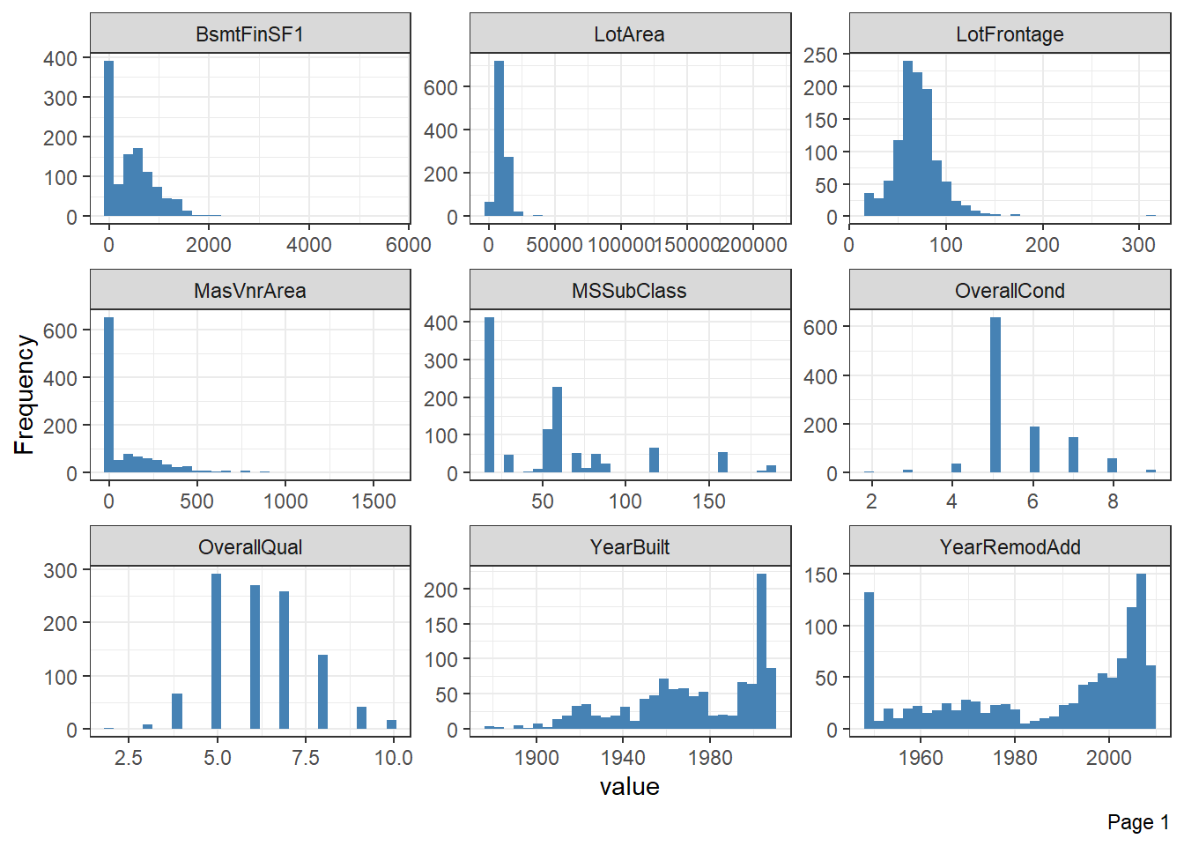

## `stat_bin()` using `bins = 30`. Pick better value with `binwidth`.

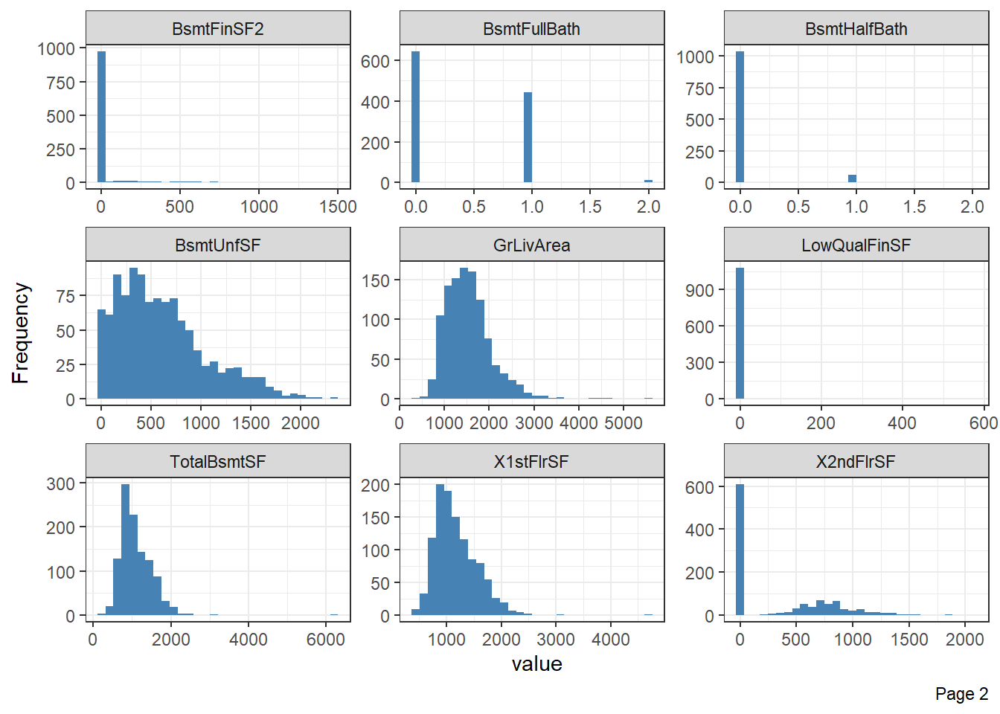

## `stat_bin()` using `bins = 30`. Pick better value with `binwidth`.

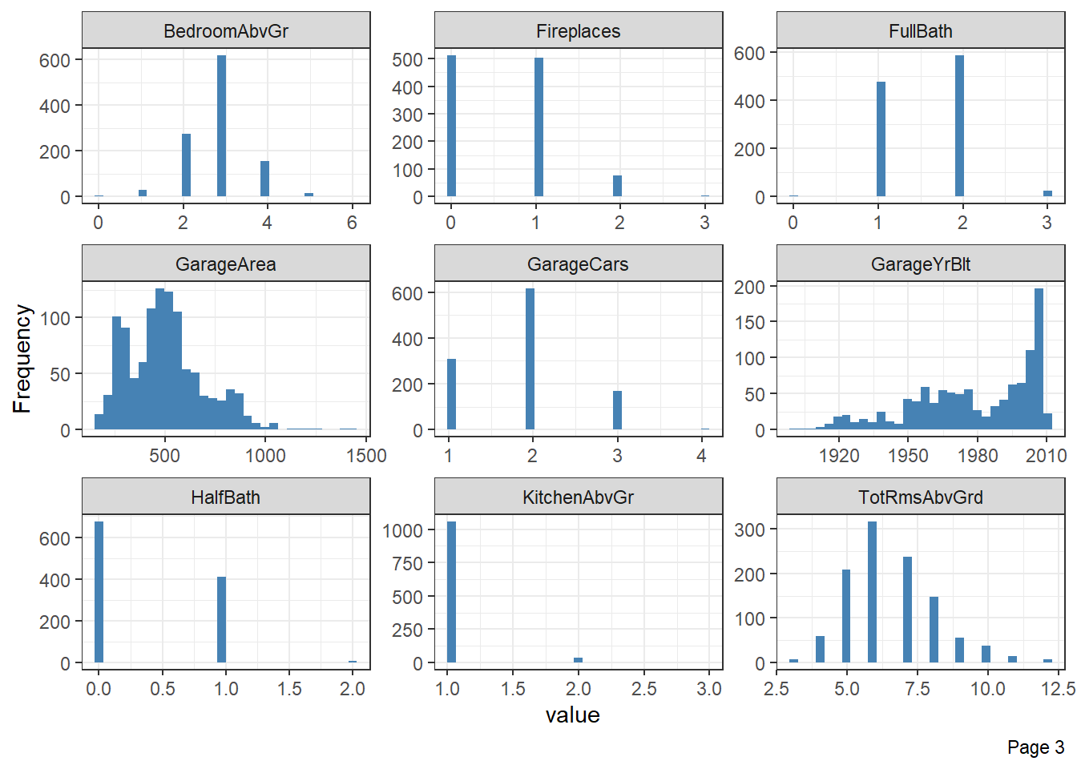

## `stat_bin()` using `bins = 30`. Pick better value with `binwidth`.

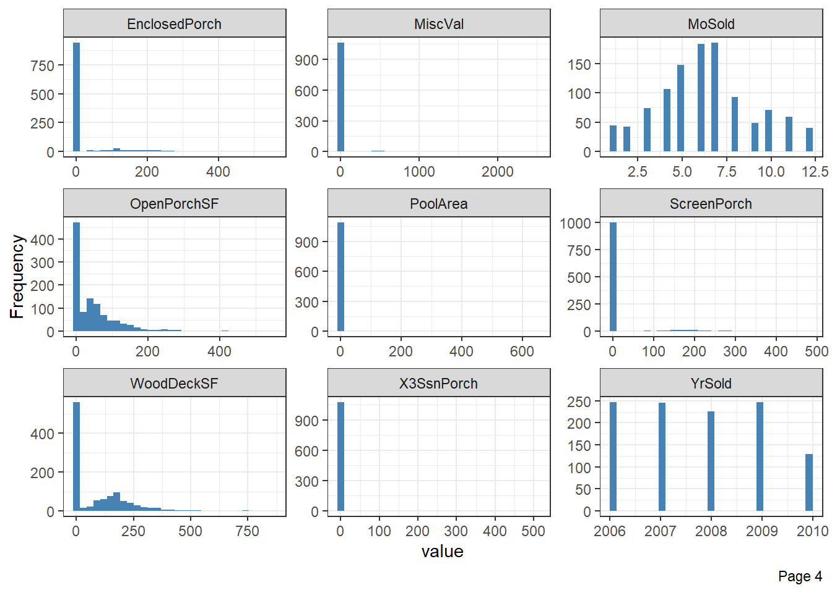

## `stat_bin()` using `bins = 30`. Pick better value with `binwidth`.

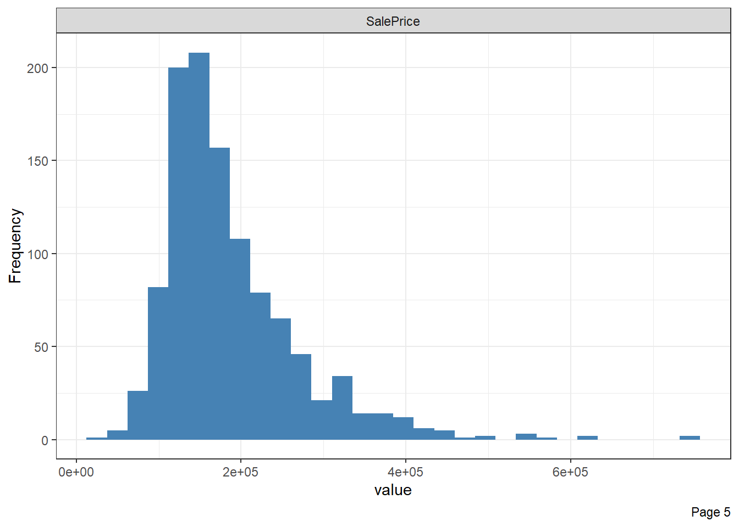

plot_bar(data = data_house1,ggtheme =theme_bw(),nrow = 1)

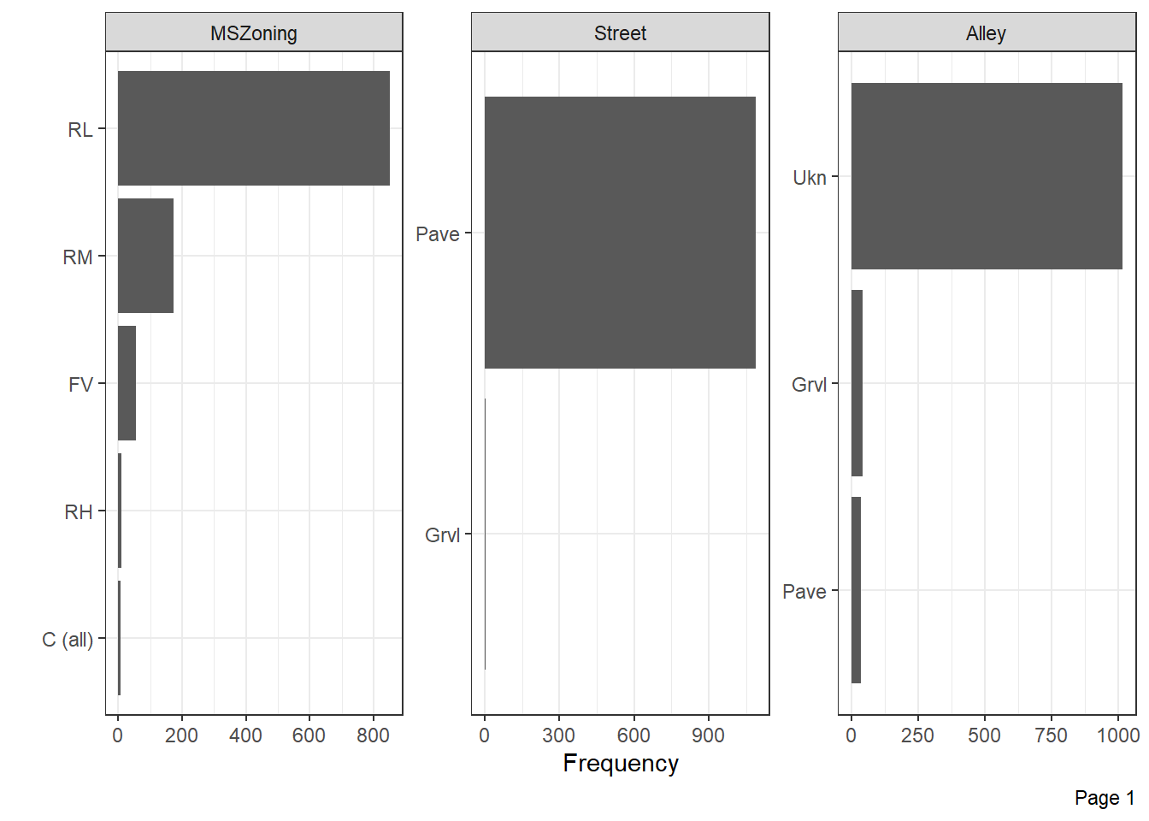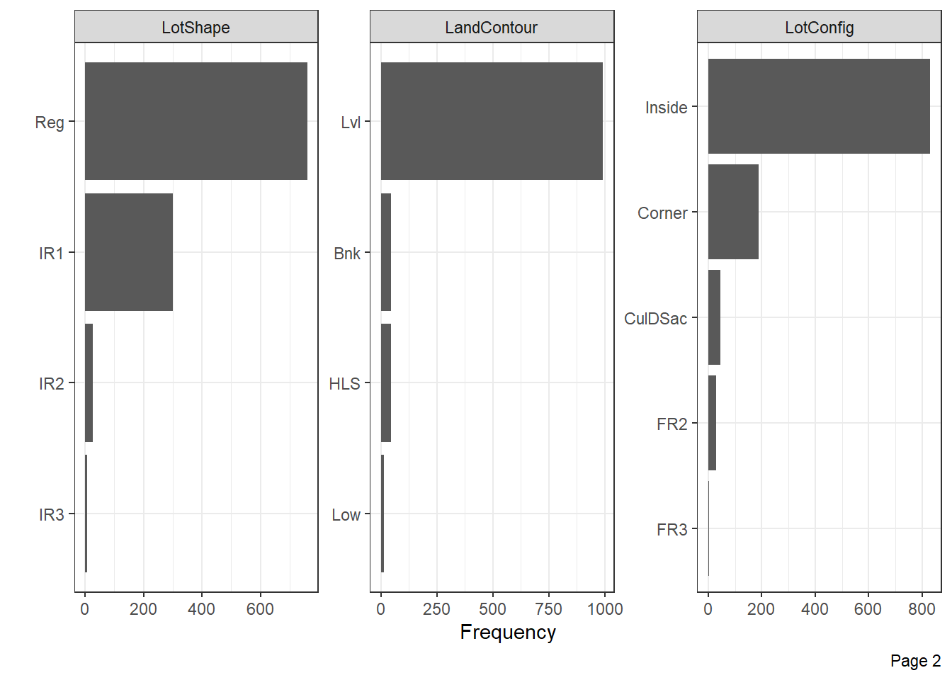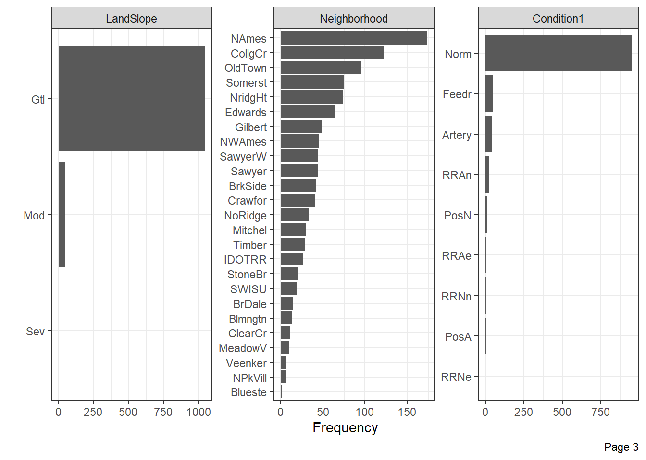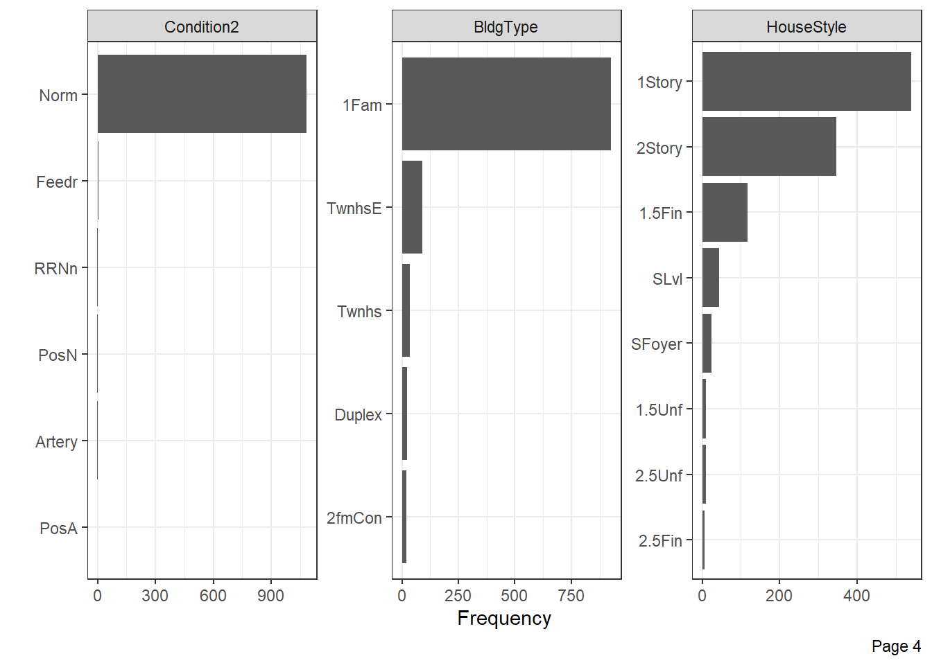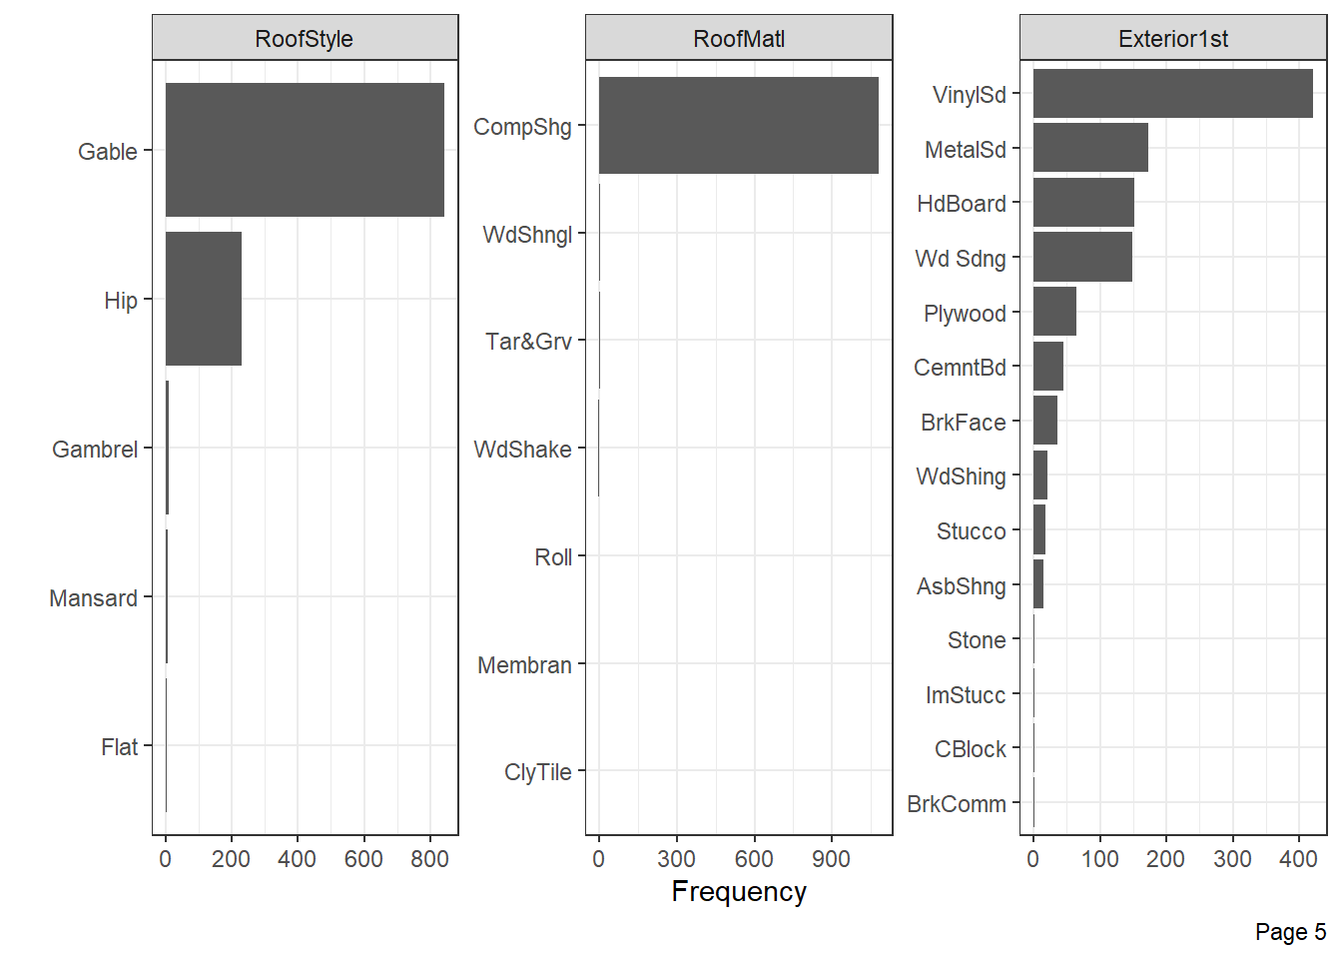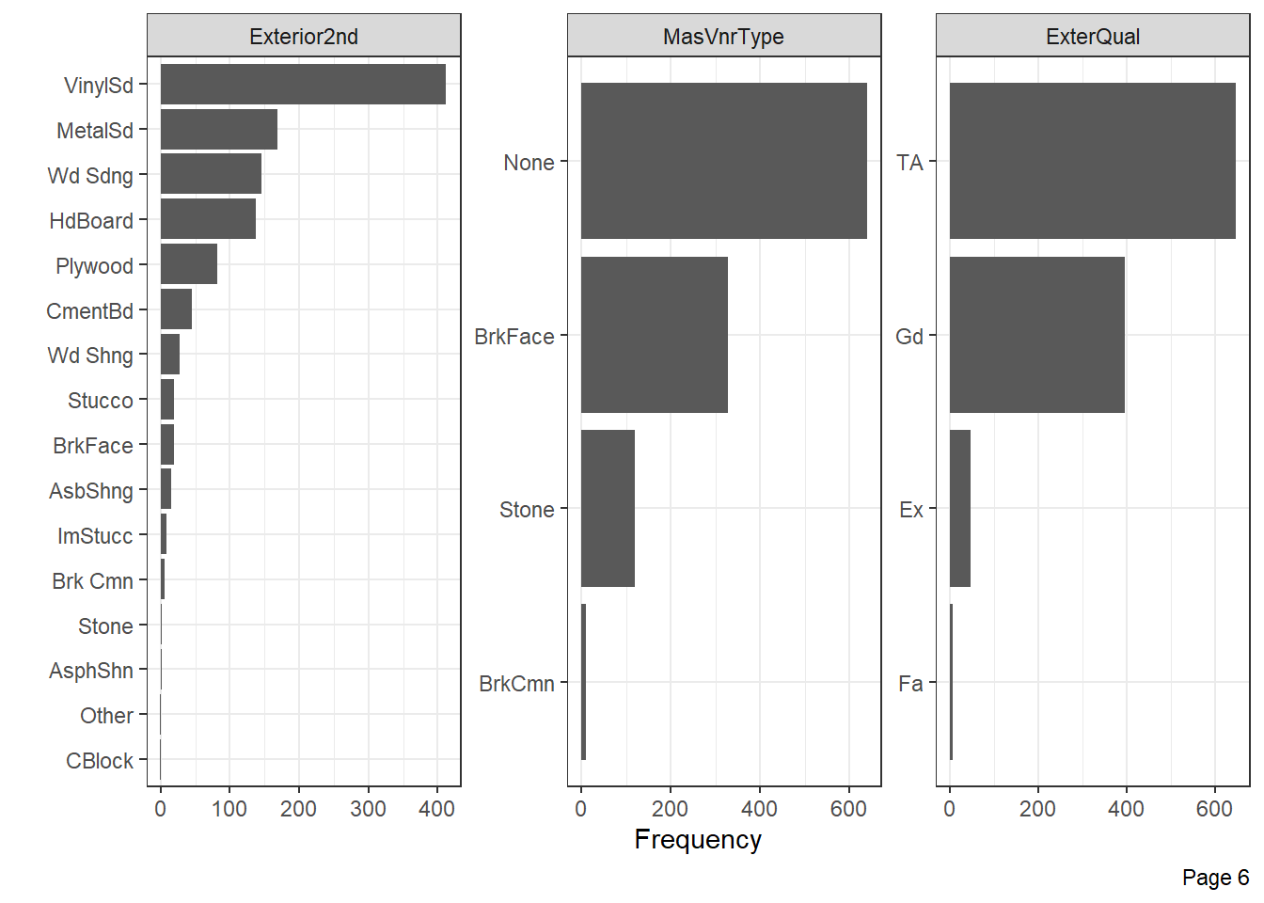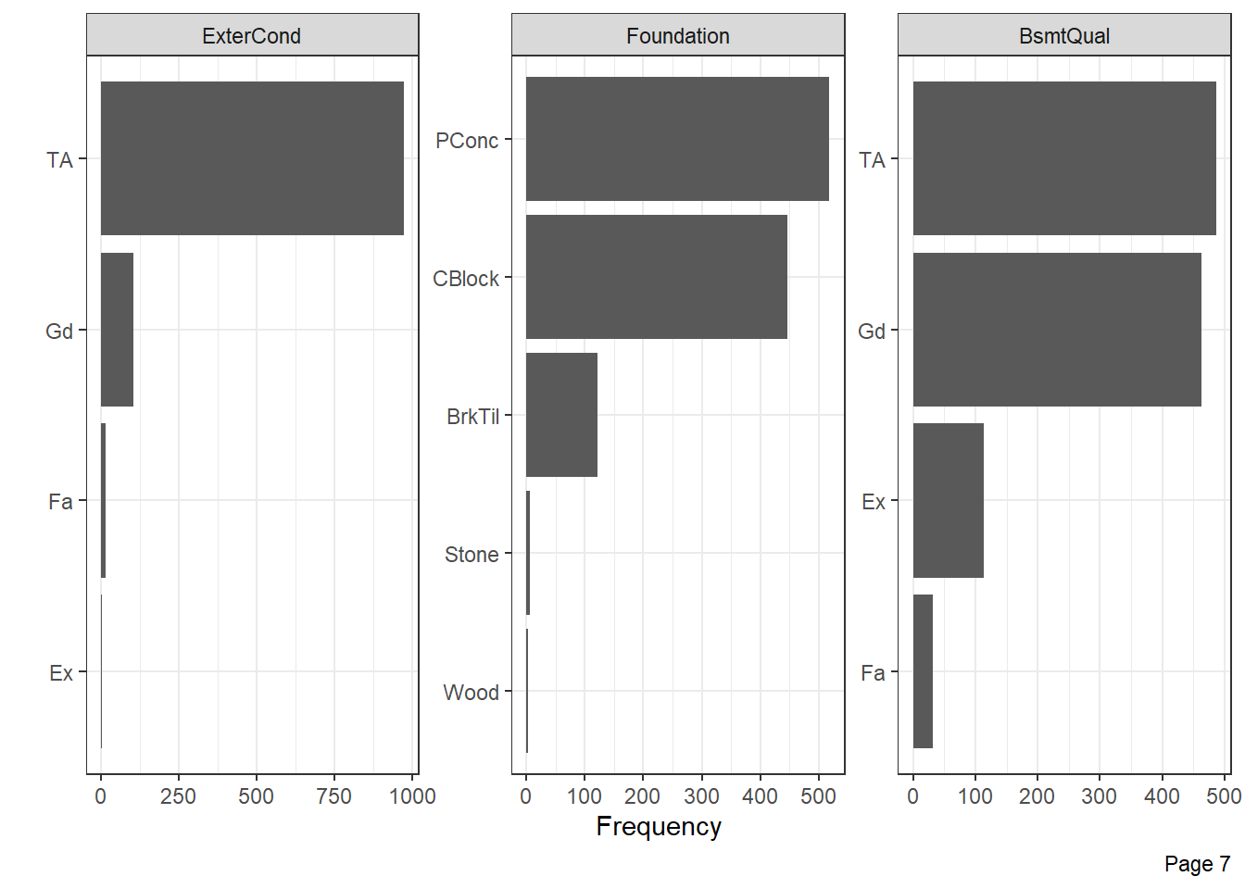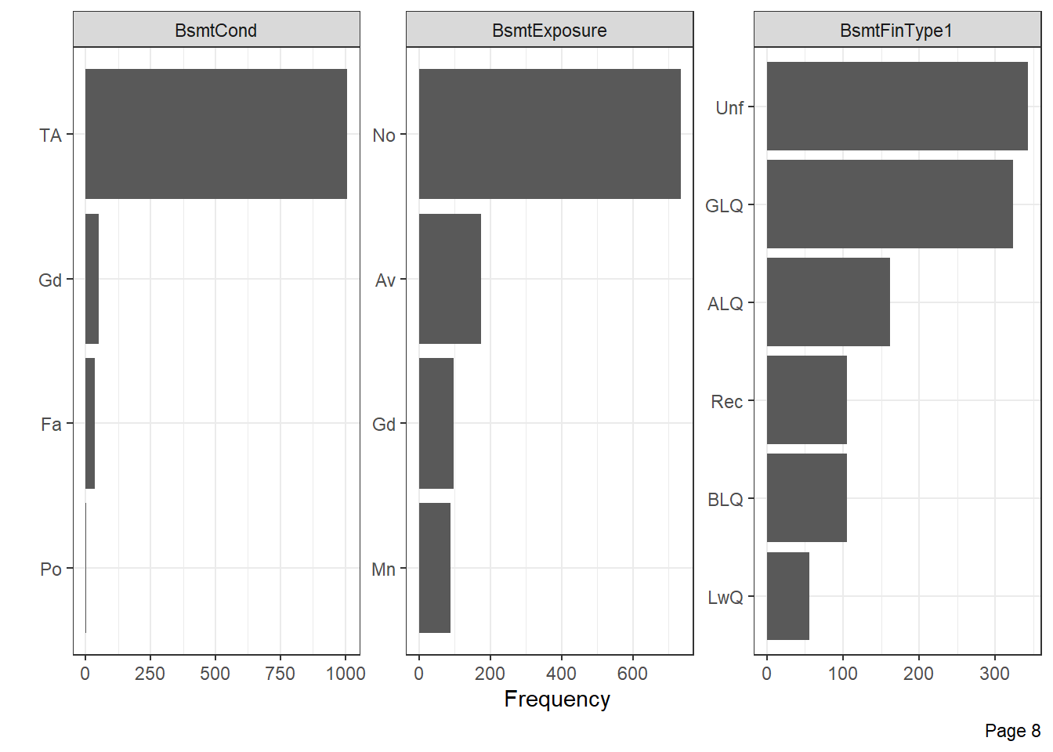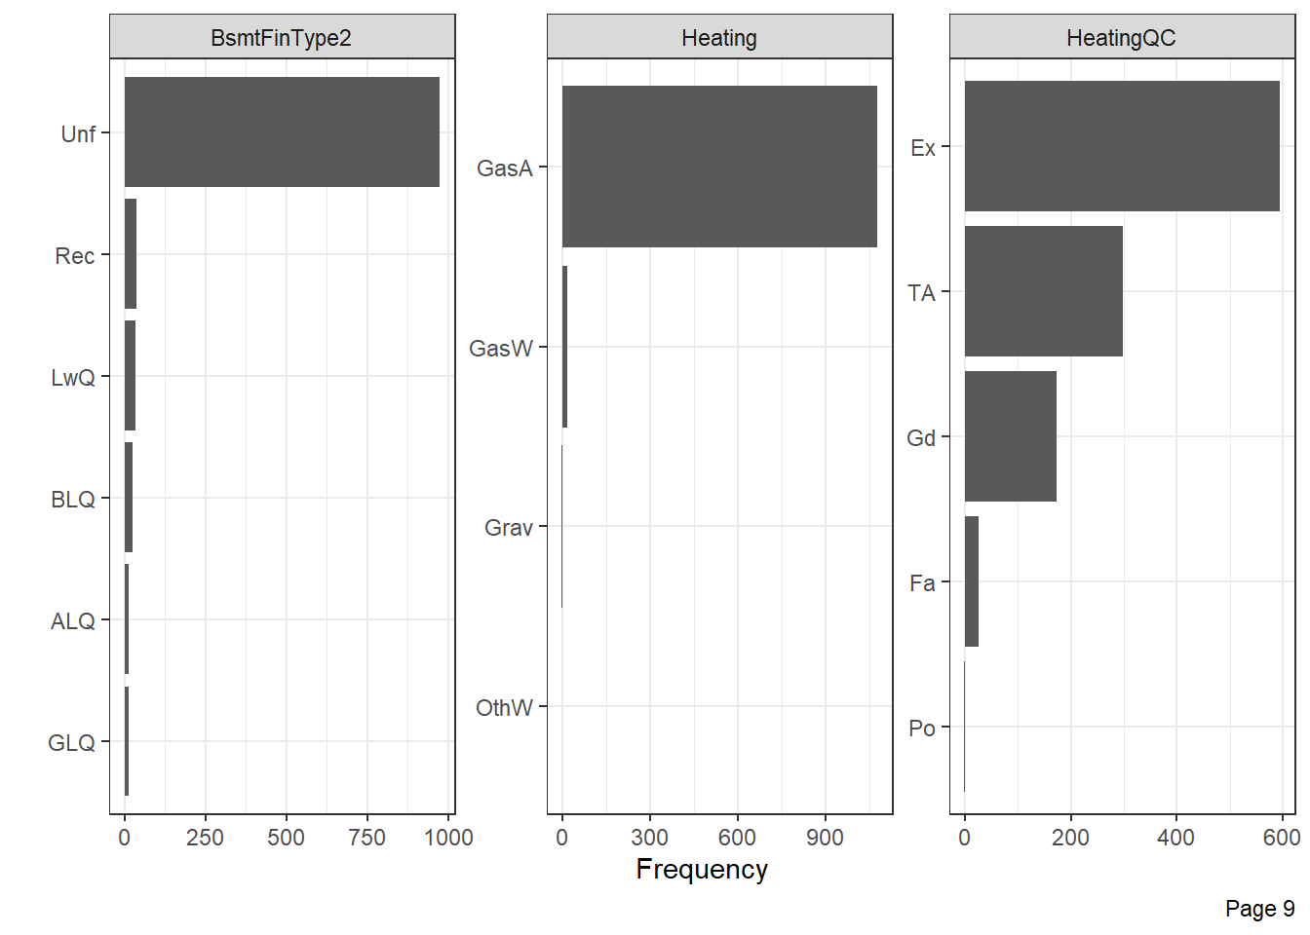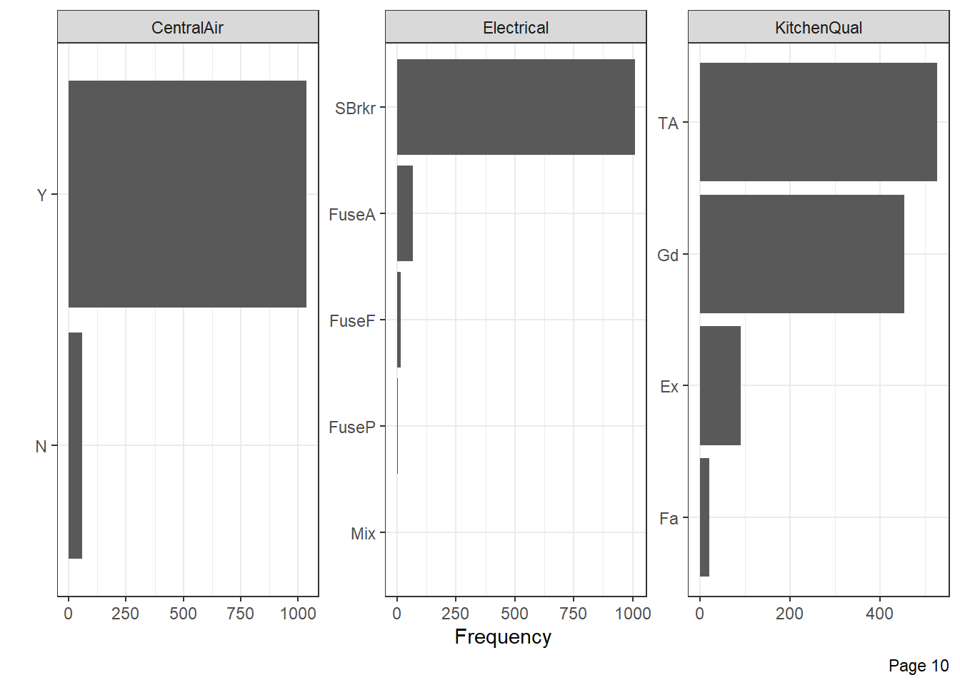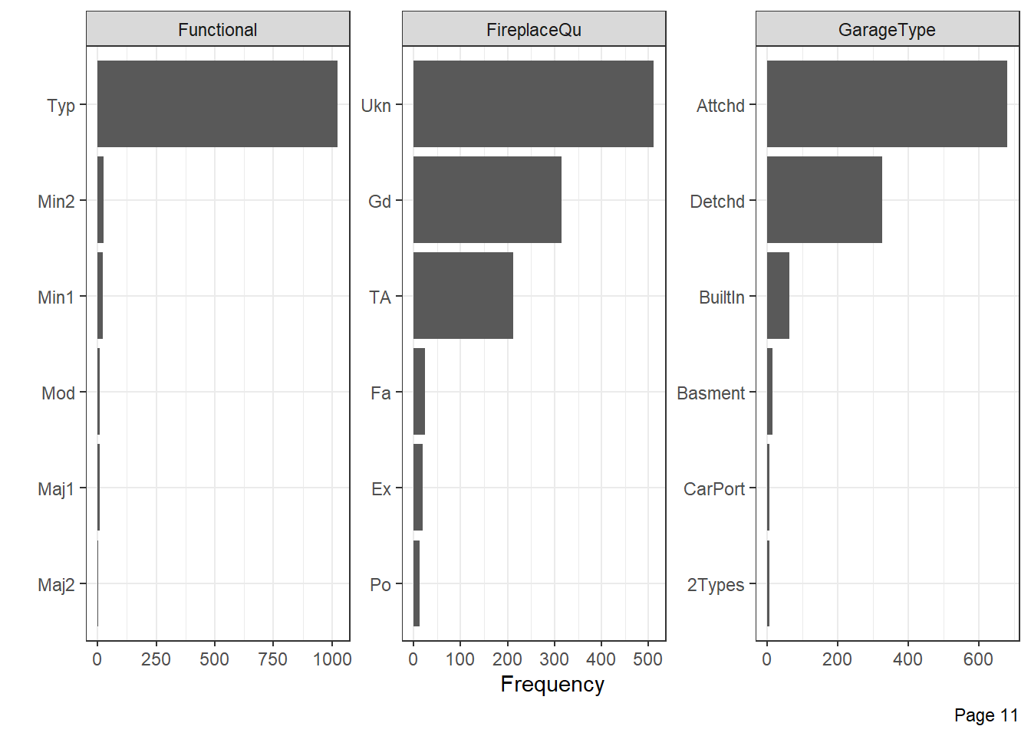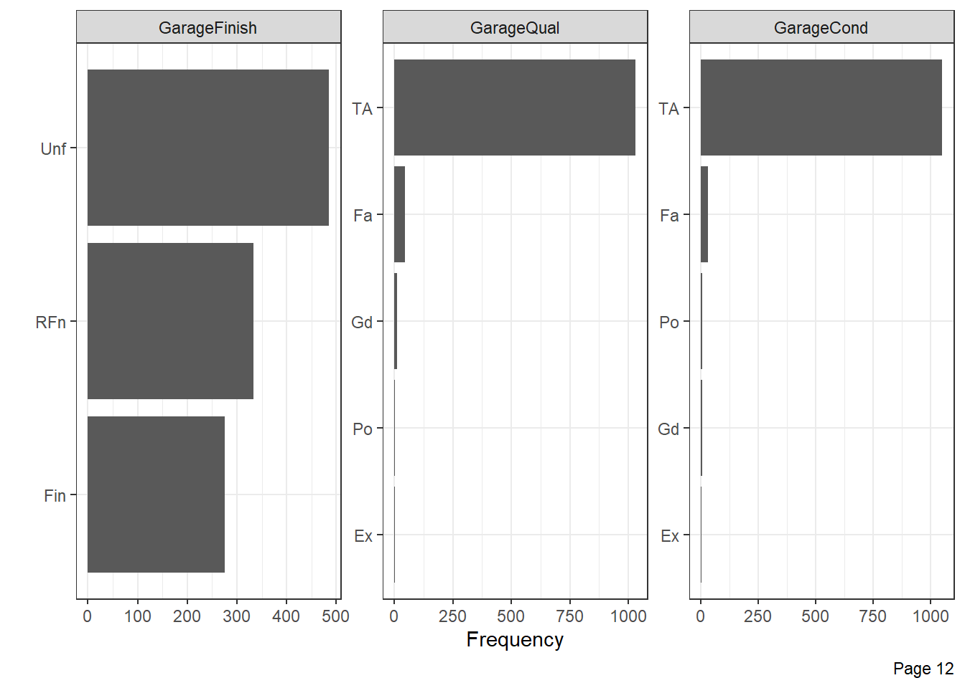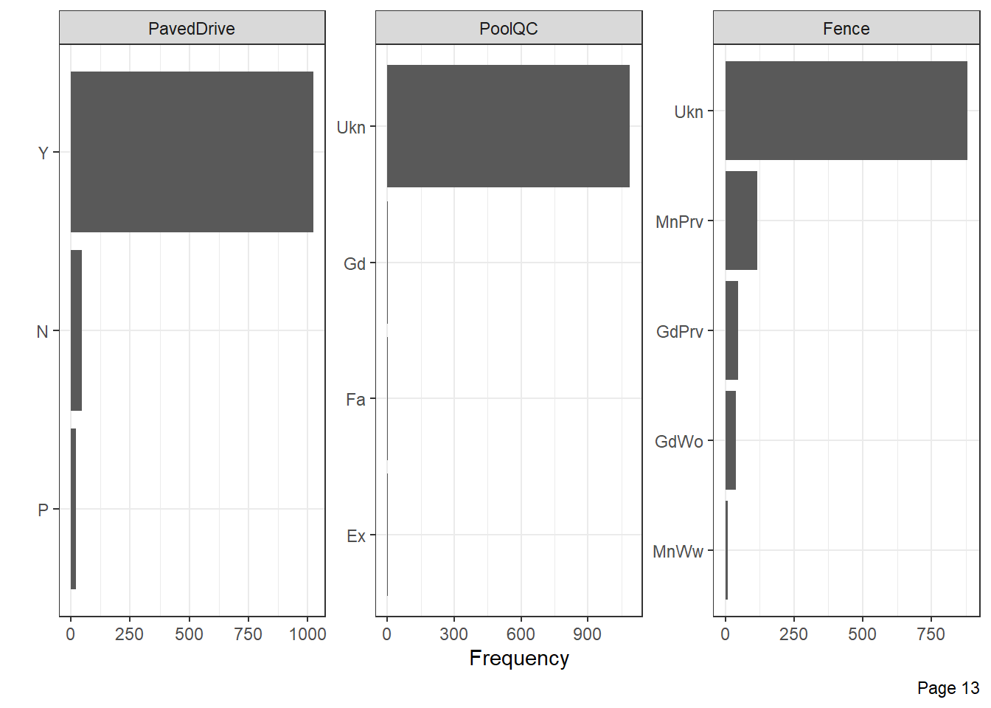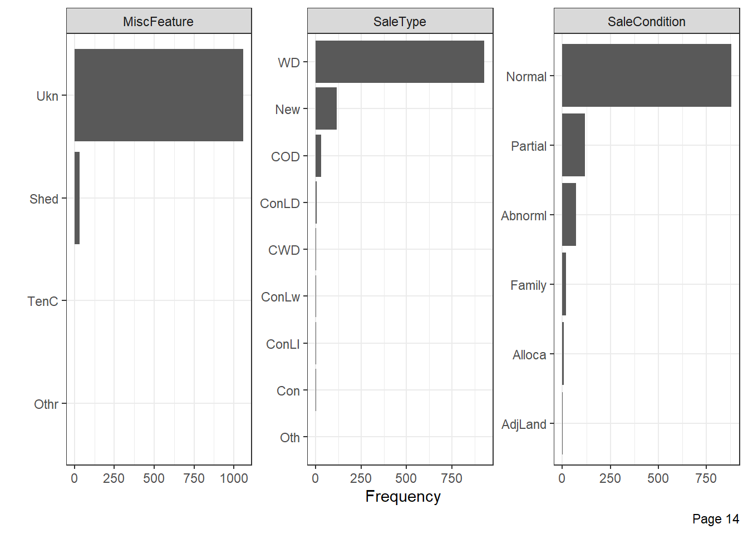

Memeriksa Korelasi Peubah

plot_scatterplot(data = data_house1 %>%  
 select_if(is.numeric),  
 by="SalePrice",geom_point_args = list(color="steelblue"),ggtheme = theme_bw() )

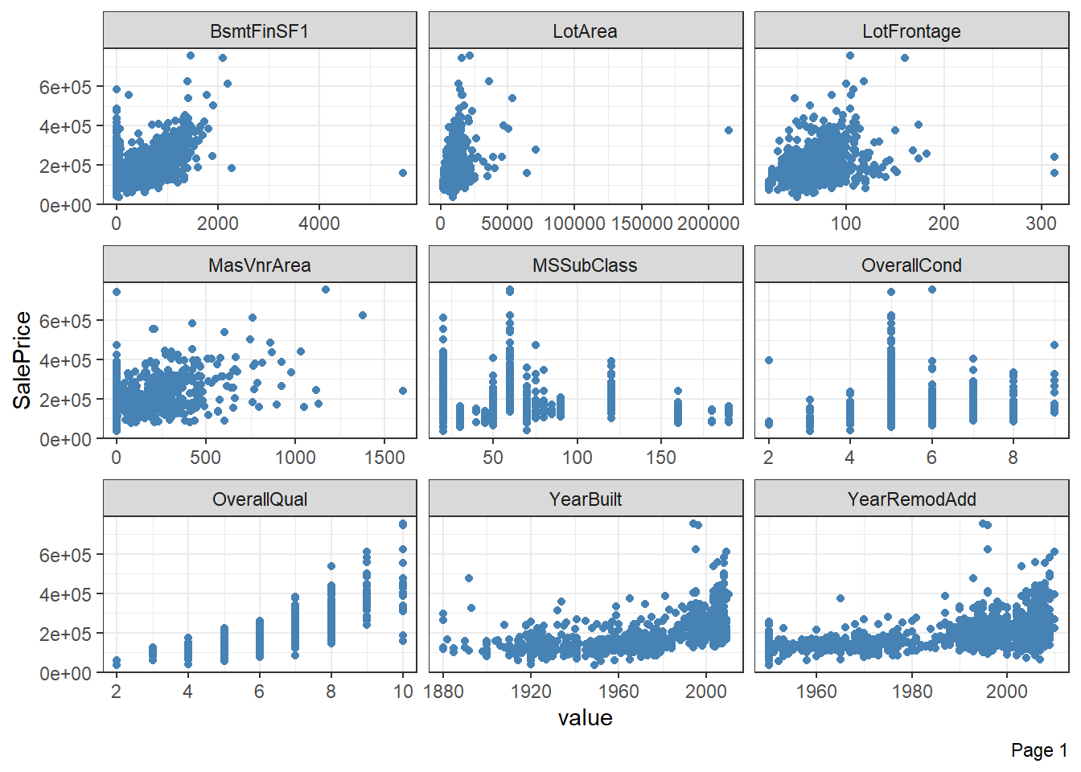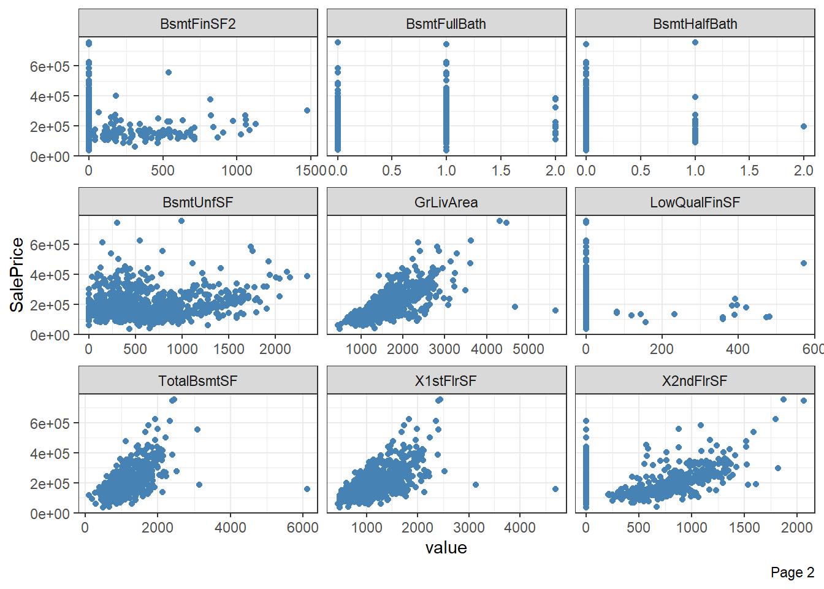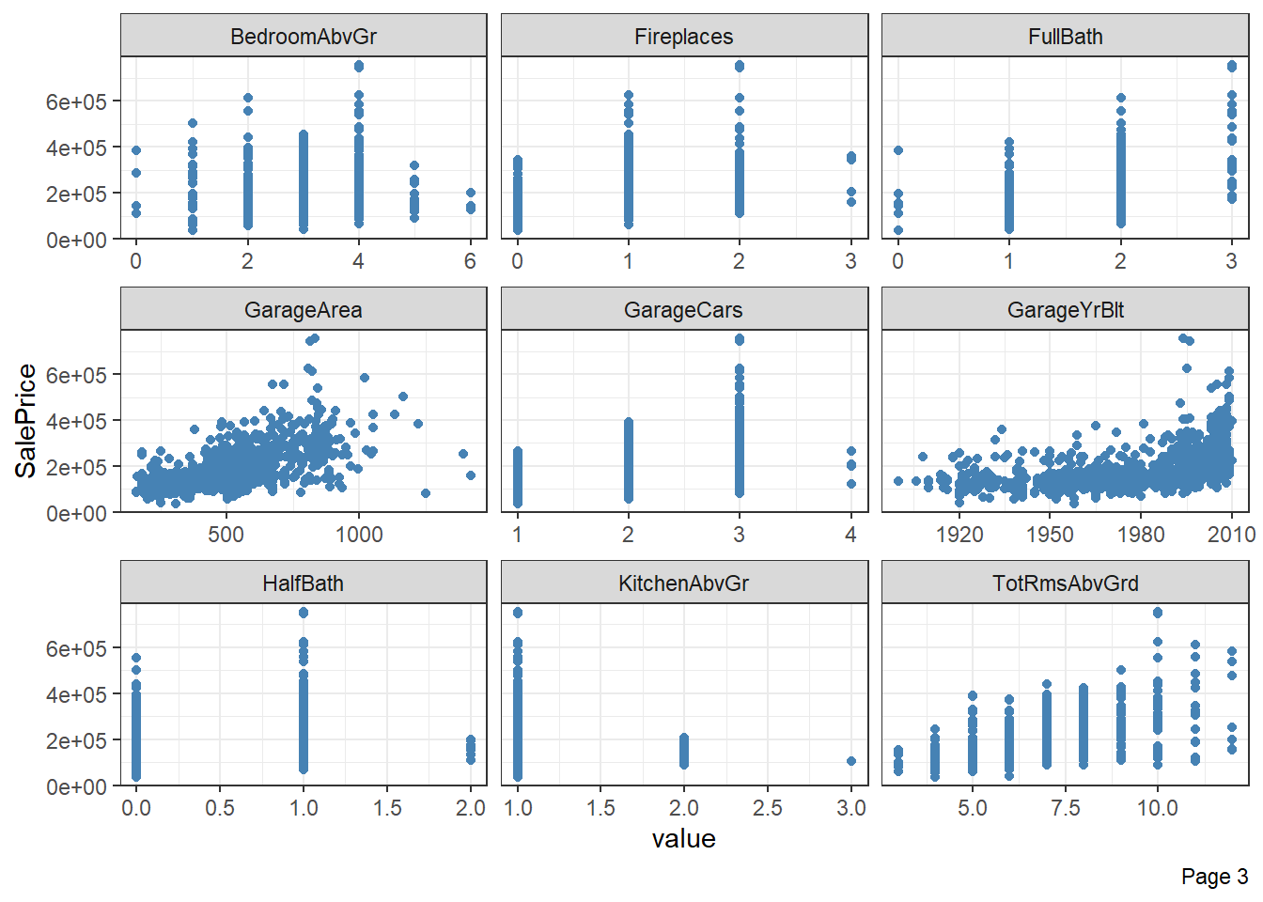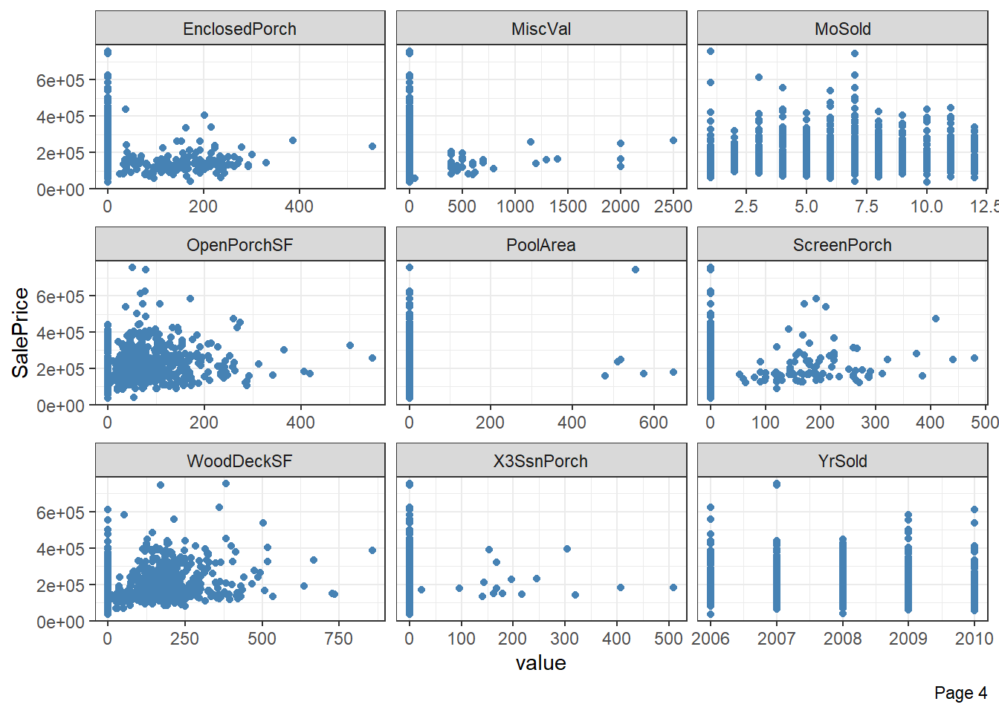

cor_mat <- cor(data_house1%>%  
 select_if(is.numeric),method = "spearman")  
cor_mat[upper.tri(cor_mat,diag = TRUE)] <- NA   
cor_df <- cor_mat %>%  
 as.data.frame() %>%   
 rownames_to_column(var = "Var1") %>%  
 pivot_longer(names_to = "Var2",  
 values_to = "corr",  
 -Var1) %>% na.omit  
  
cor_df %>% filter(abs(corr)>0.6) %>% arrange(desc(abs(corr)))

## # A tibble: 31 × 3  
## Var1 Var2 corr  
## <chr> <chr> <dbl>  
## 1 GarageYrBlt YearBuilt 0.895  
## 2 X1stFlrSF TotalBsmtSF 0.877  
## 3 GarageArea GarageCars 0.841  
## 4 TotRmsAbvGrd GrLivArea 0.829  
## 5 SalePrice OverallQual 0.823  
## 6 GarageYrBlt YearRemodAdd 0.747  
## 7 YearRemodAdd YearBuilt 0.738  
## 8 SalePrice GrLivArea 0.731  
## 9 SalePrice GarageCars 0.681  
## 10 SalePrice FullBath 0.671  
## # … with 21 more rows

cor_df %>% filter(abs(corr)<=0.6)

## # A tibble: 635 × 3  
## Var1 Var2 corr  
## <chr> <chr> <dbl>  
## 1 LotFrontage MSSubClass -0.313   
## 2 LotArea MSSubClass -0.255   
## 3 OverallQual MSSubClass 0.0992   
## 4 OverallQual LotFrontage 0.238   
## 5 OverallQual LotArea 0.283   
## 6 OverallCond MSSubClass -0.0763   
## 7 OverallCond LotFrontage -0.0693   
## 8 OverallCond LotArea -0.0873   
## 9 OverallCond OverallQual -0.264   
## 10 YearBuilt MSSubClass -0.00468  
## # … with 625 more rows

cat_var_names <- data_house1 %>%   
 select(where(is.factor),SalePrice) %>%  
 names  
cat_var_names

## [1] "MSZoning" "Street" "Alley" "LotShape"   
## [5] "LandContour" "LotConfig" "LandSlope" "Neighborhood"   
## [9] "Condition1" "Condition2" "BldgType" "HouseStyle"   
## [13] "RoofStyle" "RoofMatl" "Exterior1st" "Exterior2nd"   
## [17] "MasVnrType" "ExterQual" "ExterCond" "Foundation"   
## [21] "BsmtQual" "BsmtCond" "BsmtExposure" "BsmtFinType1"   
## [25] "BsmtFinType2" "Heating" "HeatingQC" "CentralAir"   
## [29] "Electrical" "KitchenQual" "Functional" "FireplaceQu"   
## [33] "GarageType" "GarageFinish" "GarageQual" "GarageCond"   
## [37] "PavedDrive" "PoolQC" "Fence" "MiscFeature"   
## [41] "SaleType" "SaleCondition" "SalePrice"

for(i in cat_var_names[-43]){  
plot_boxplot(data = data_house1 %>%   
 select(where(is.factor),SalePrice),  
 geom_boxplot_args=list(fill="steelblue"),  
 by=i,ggtheme = theme_bw())  
}

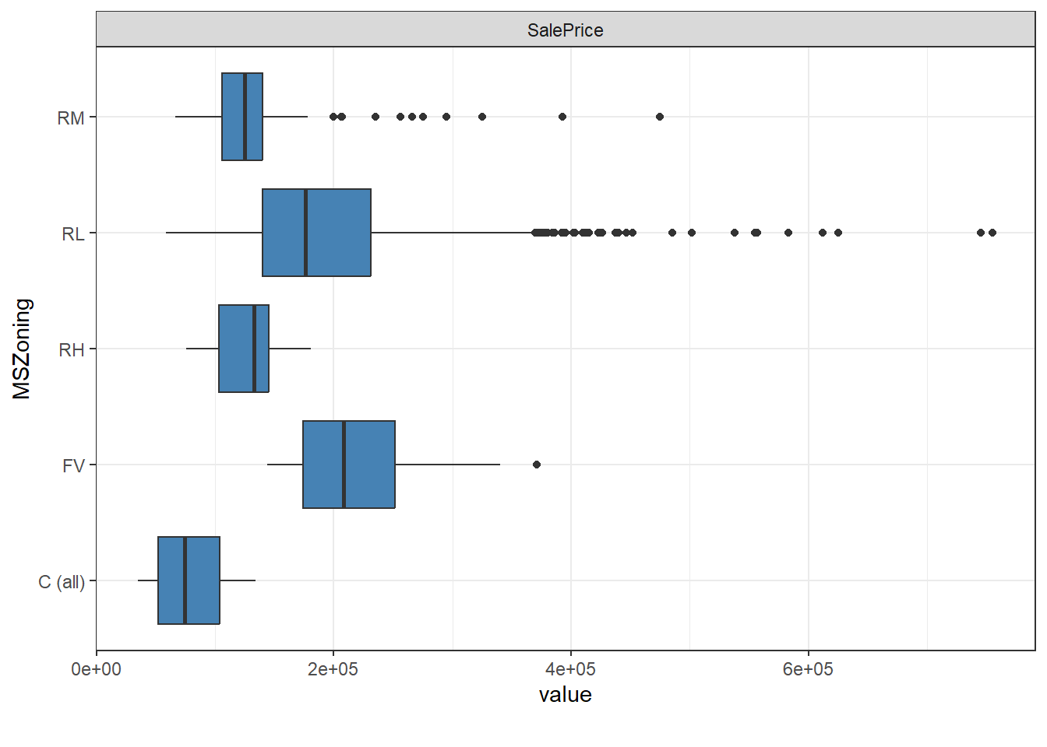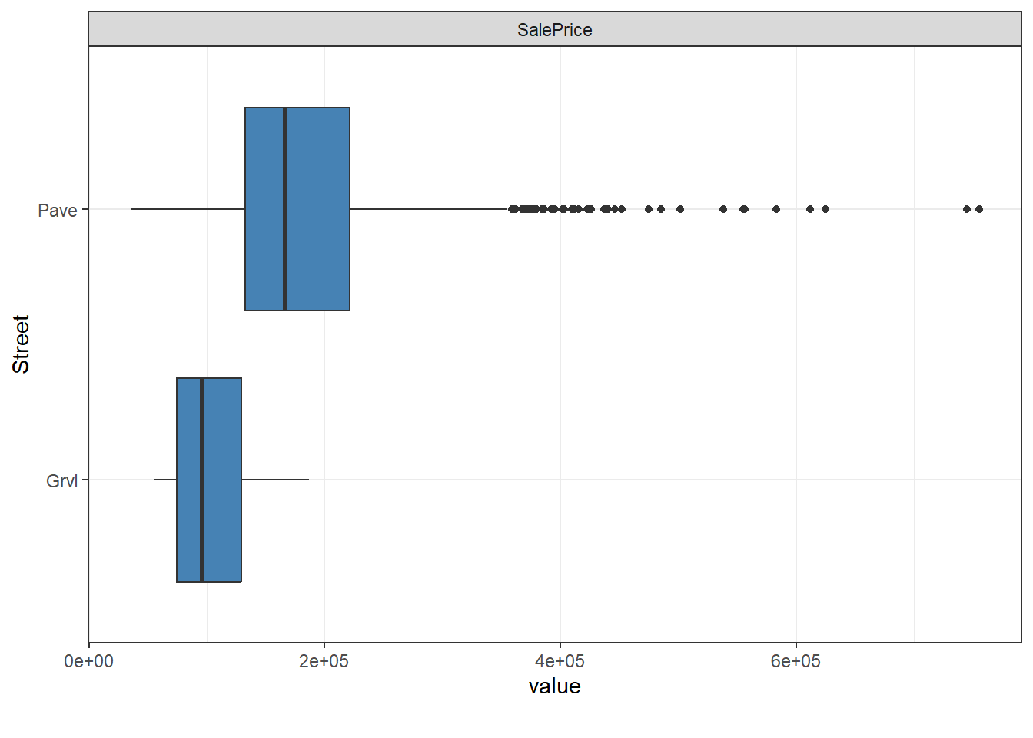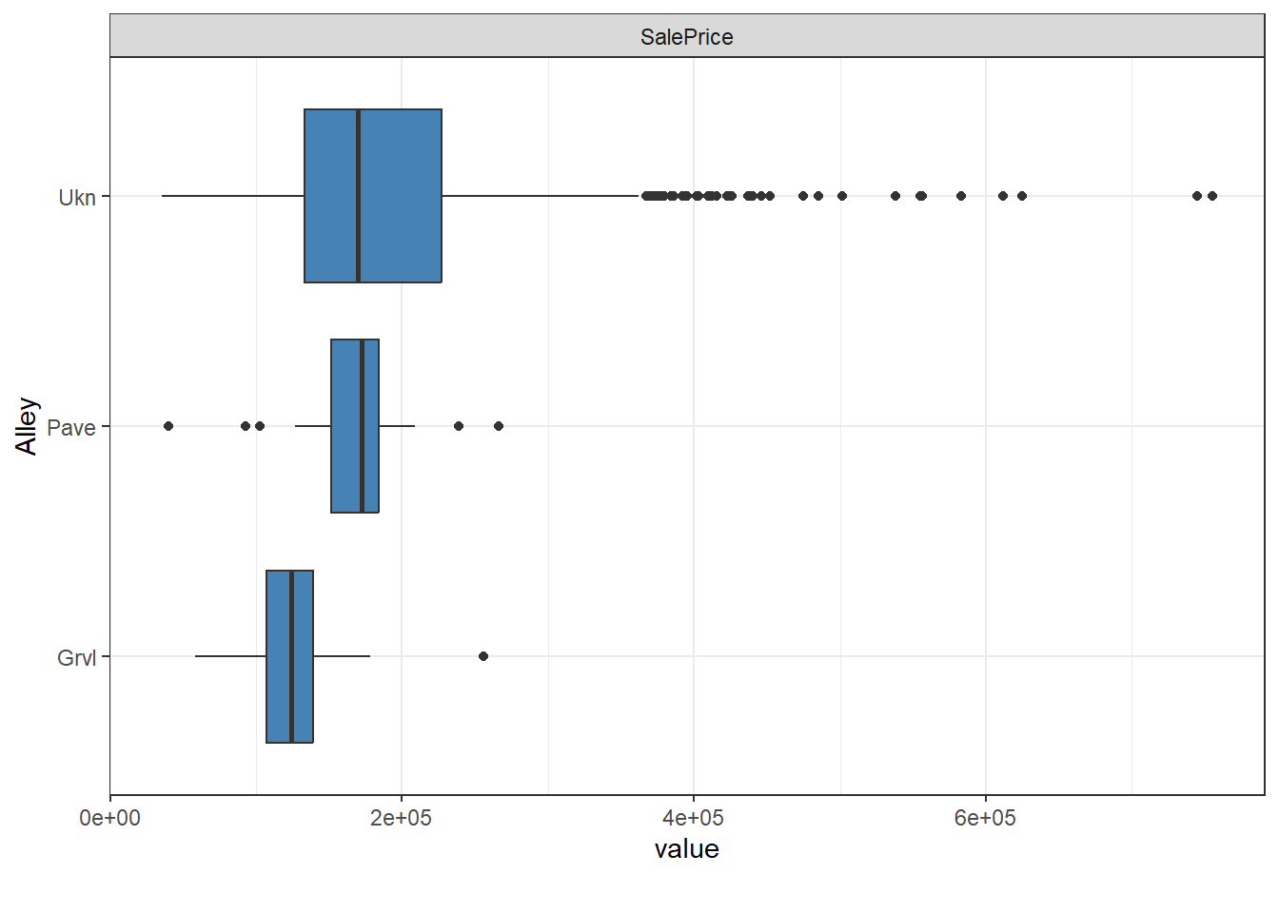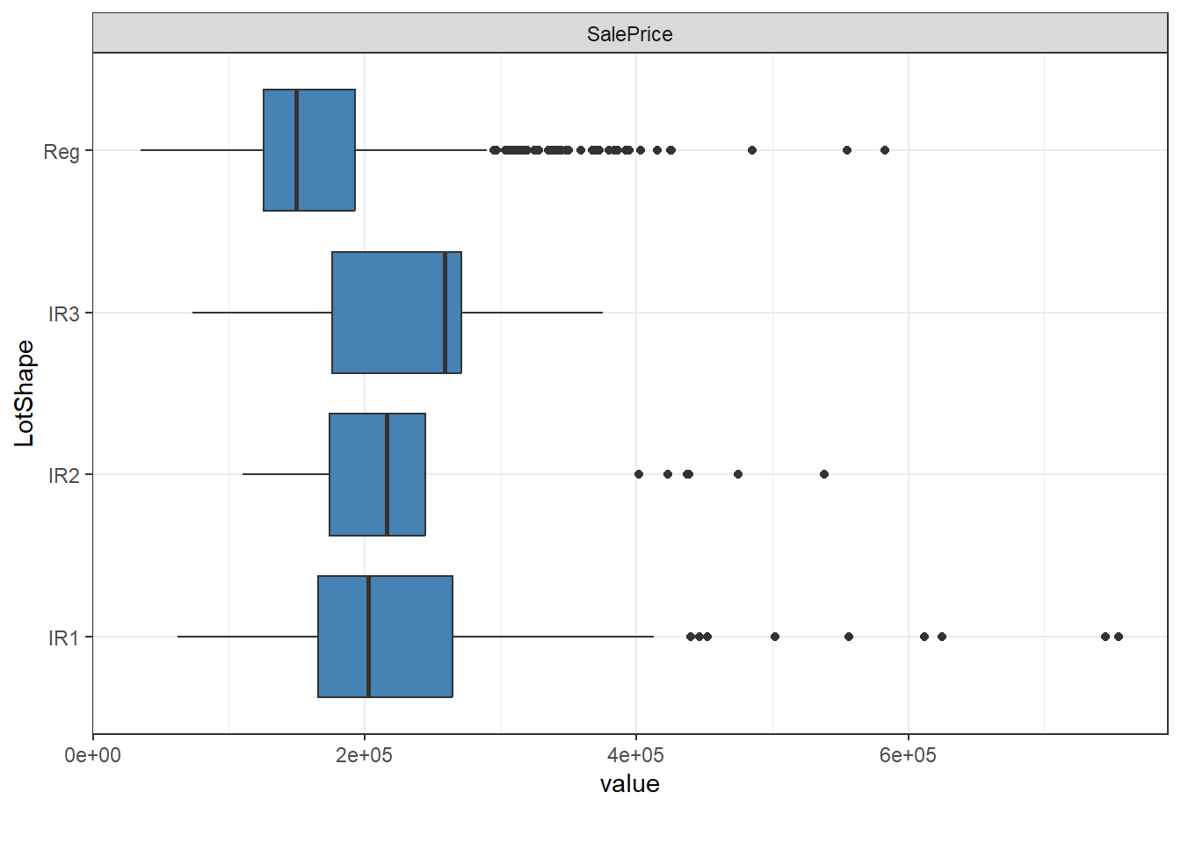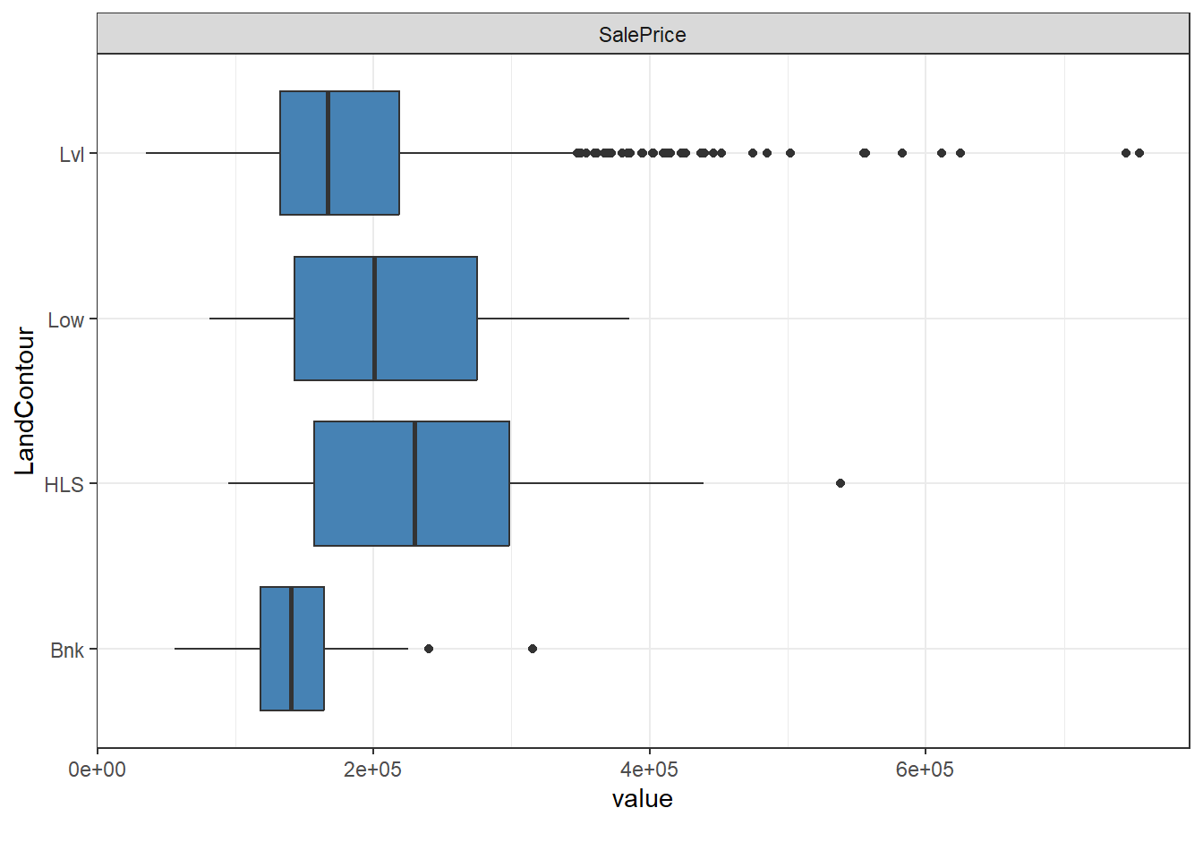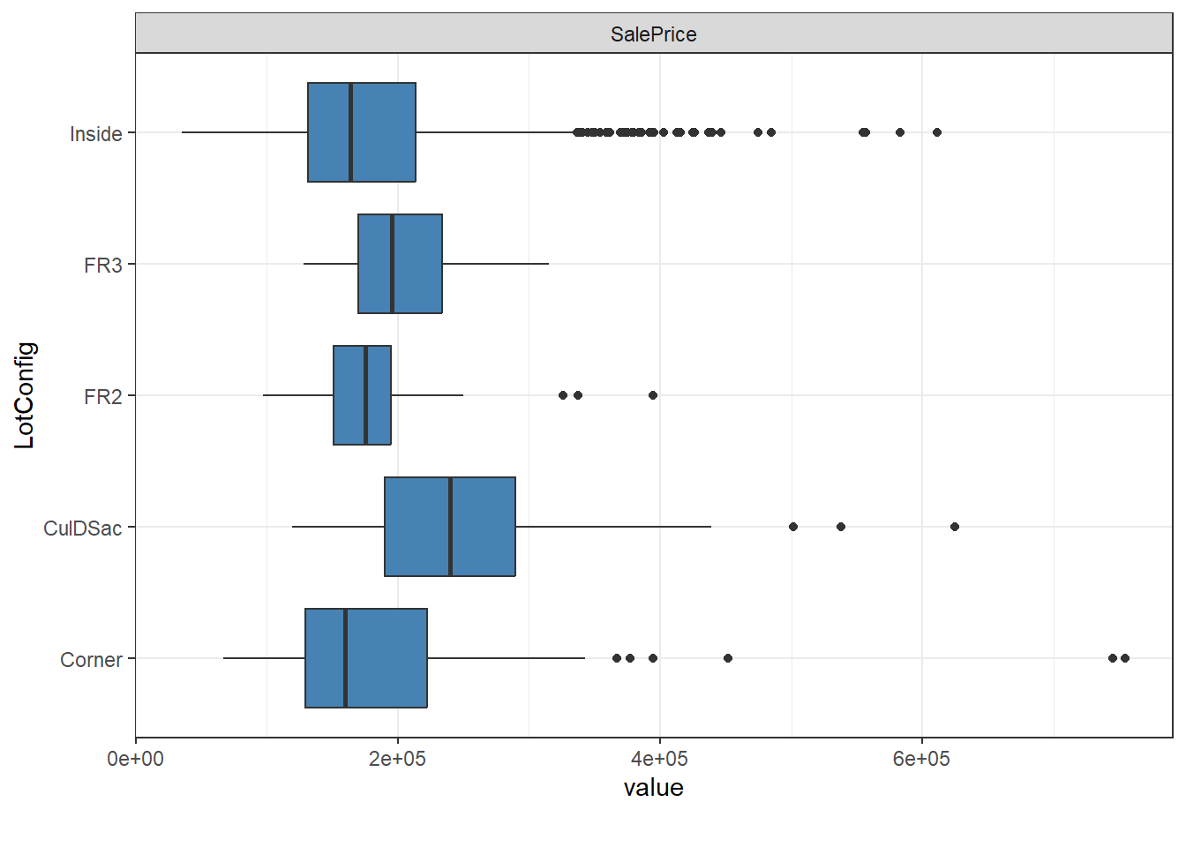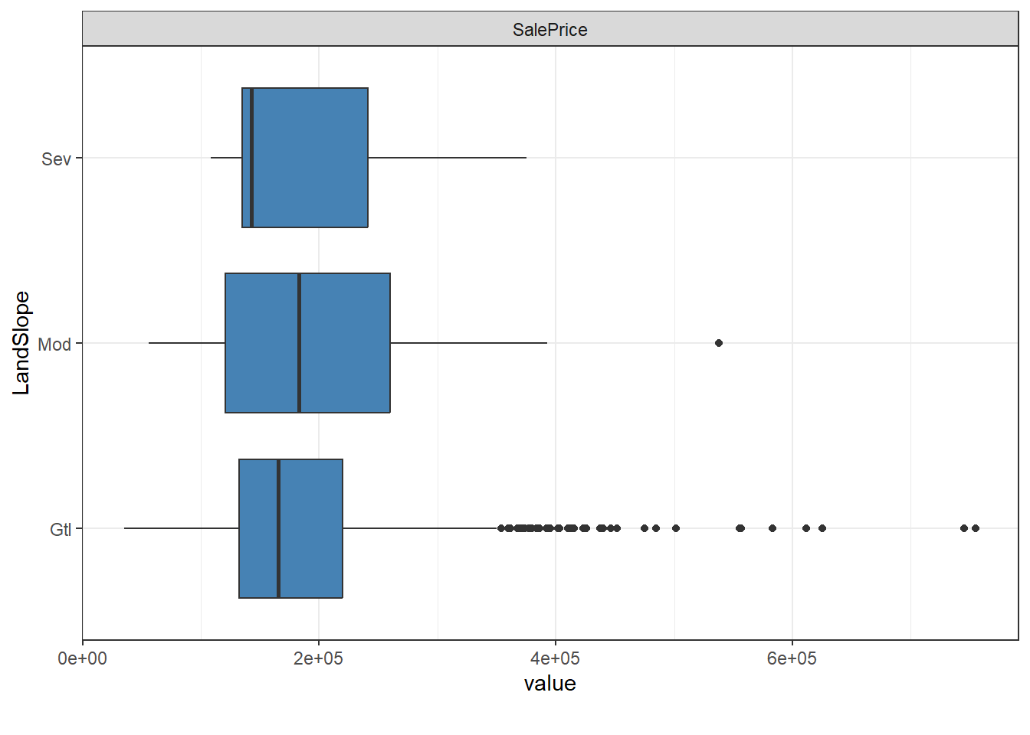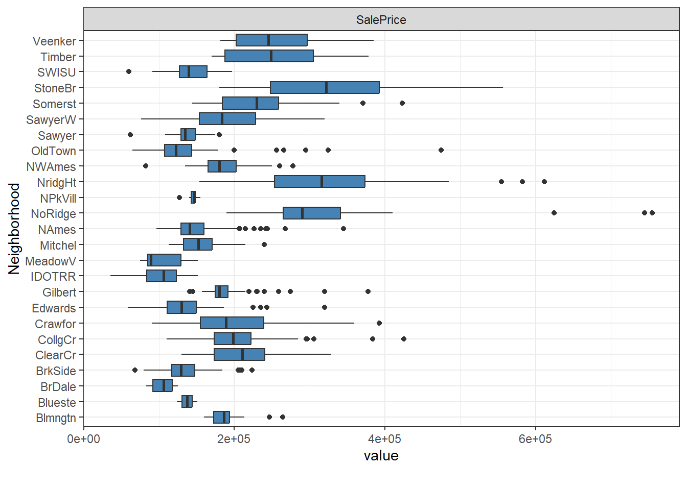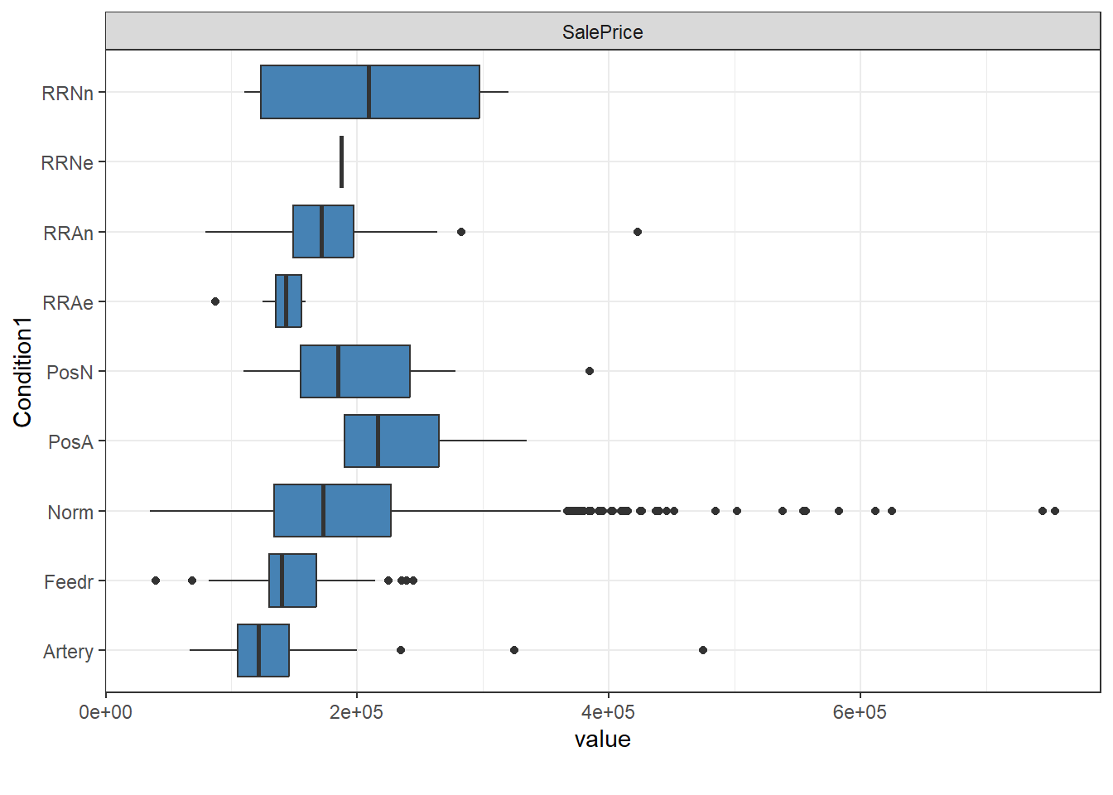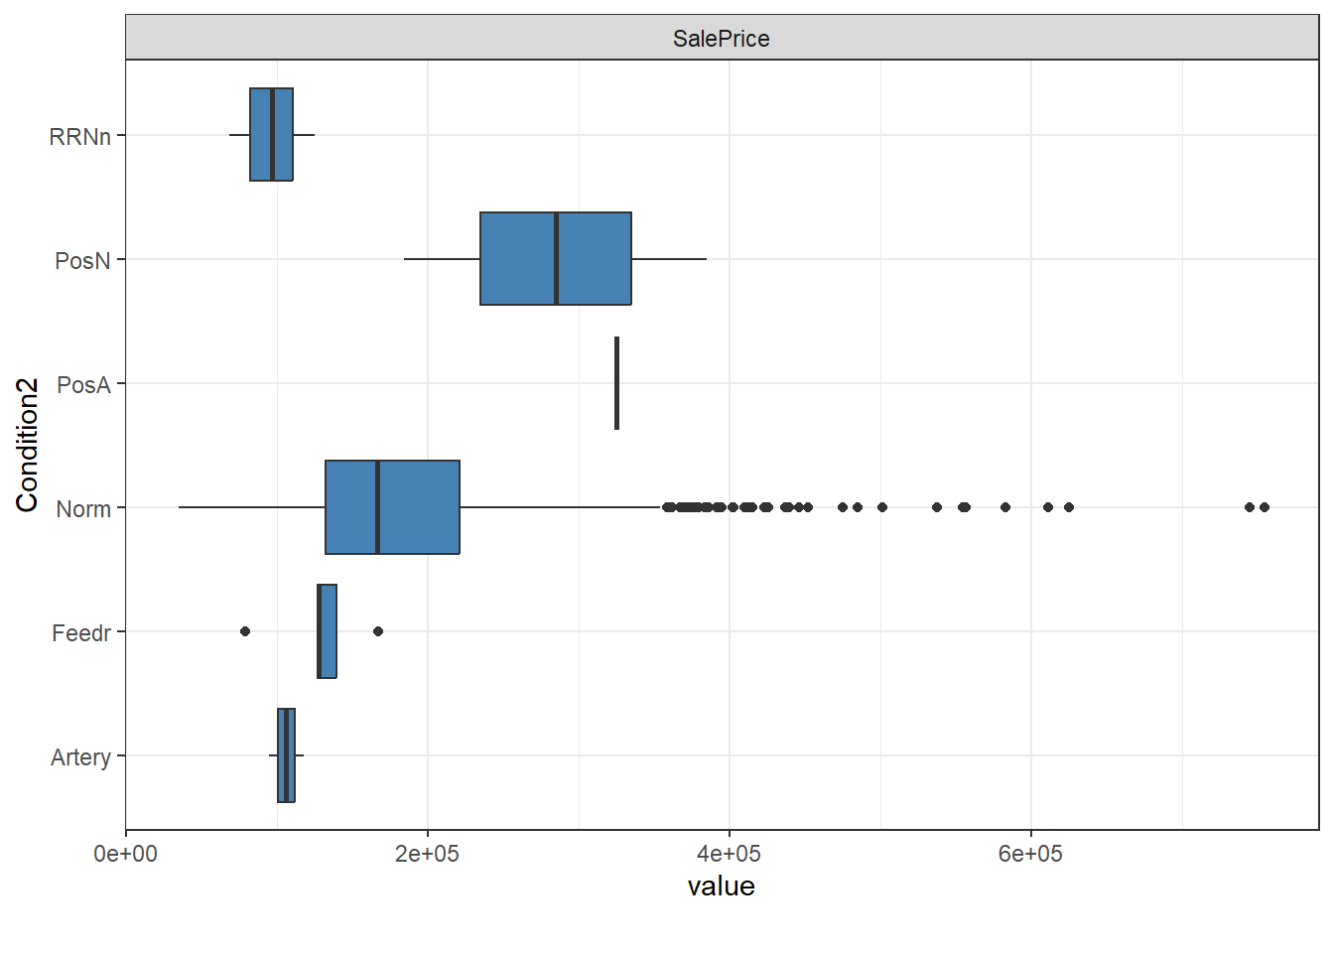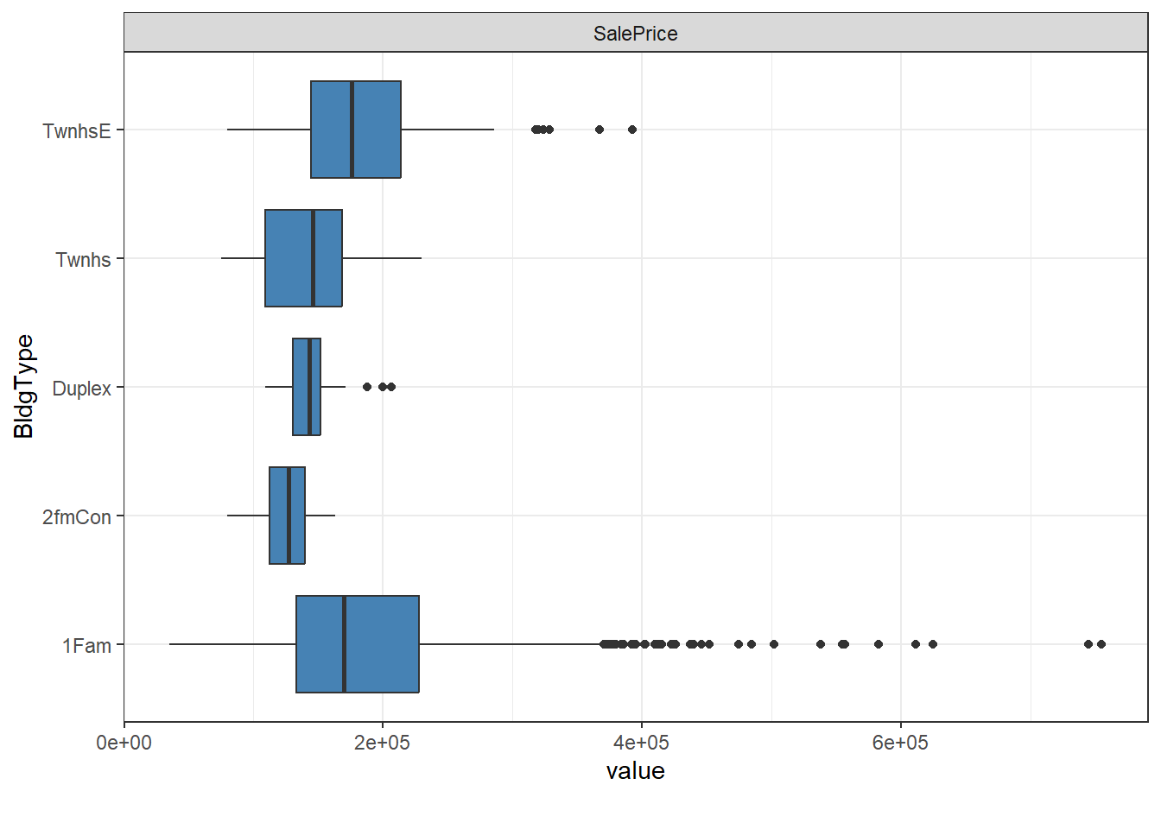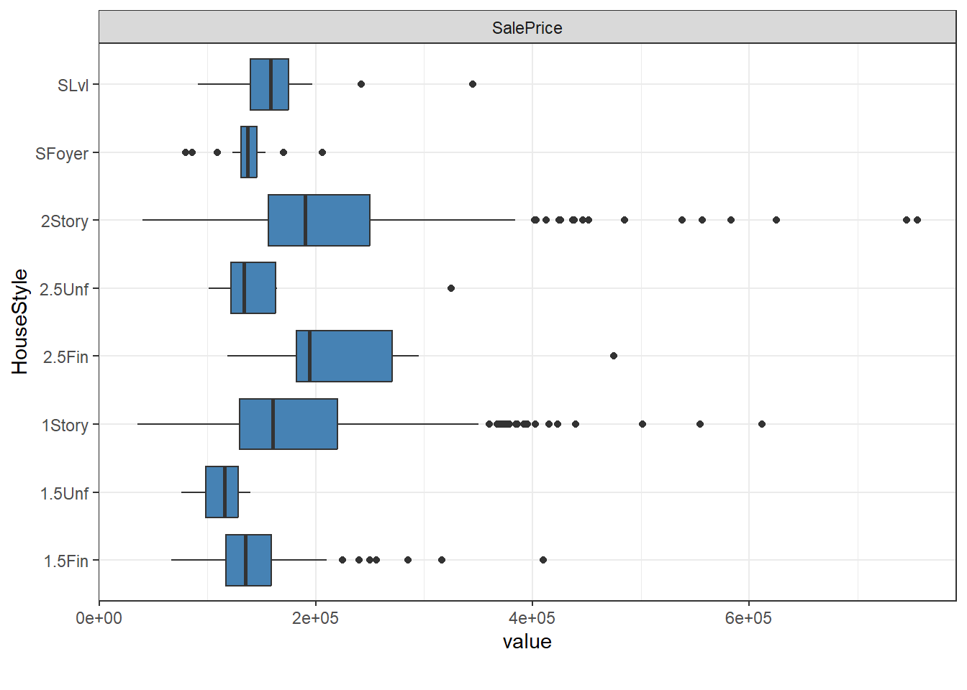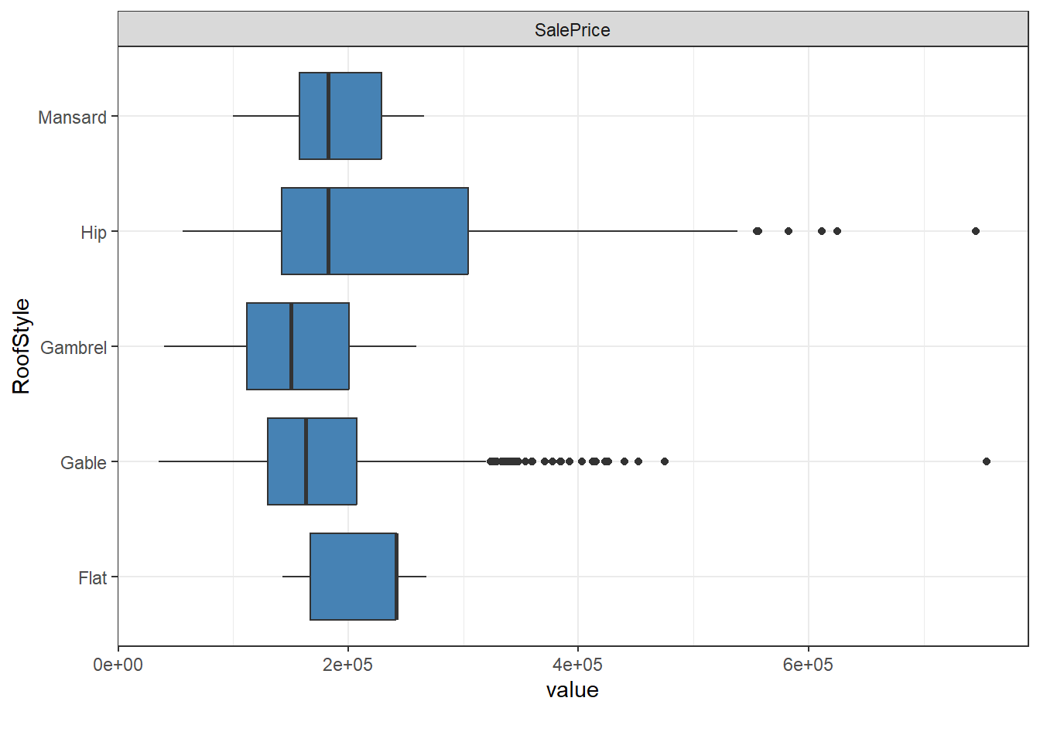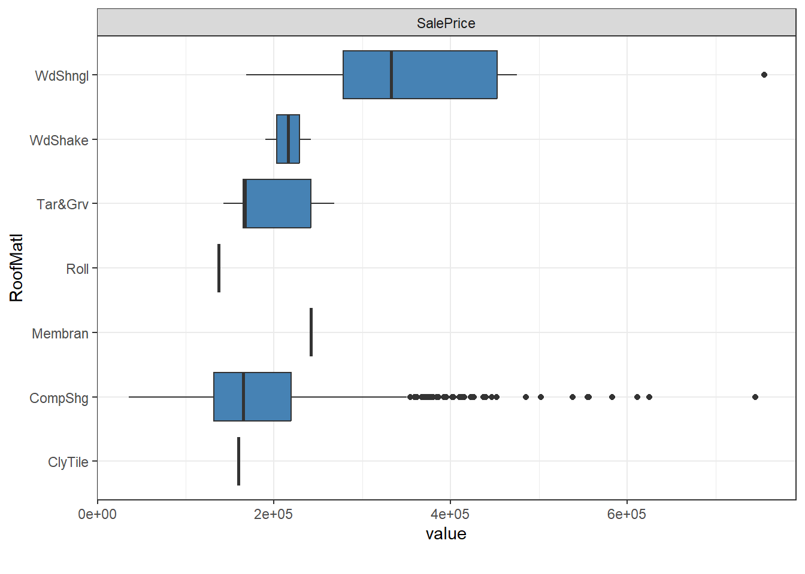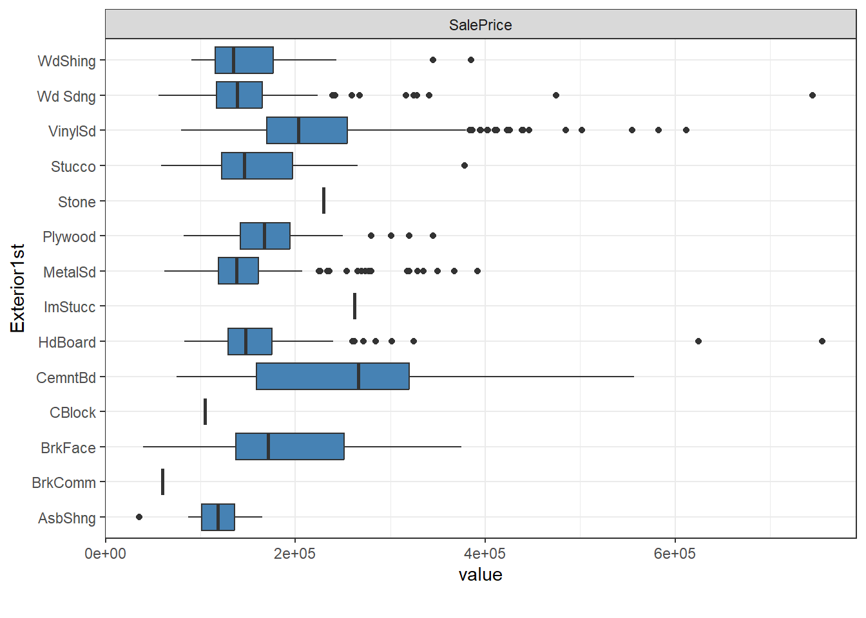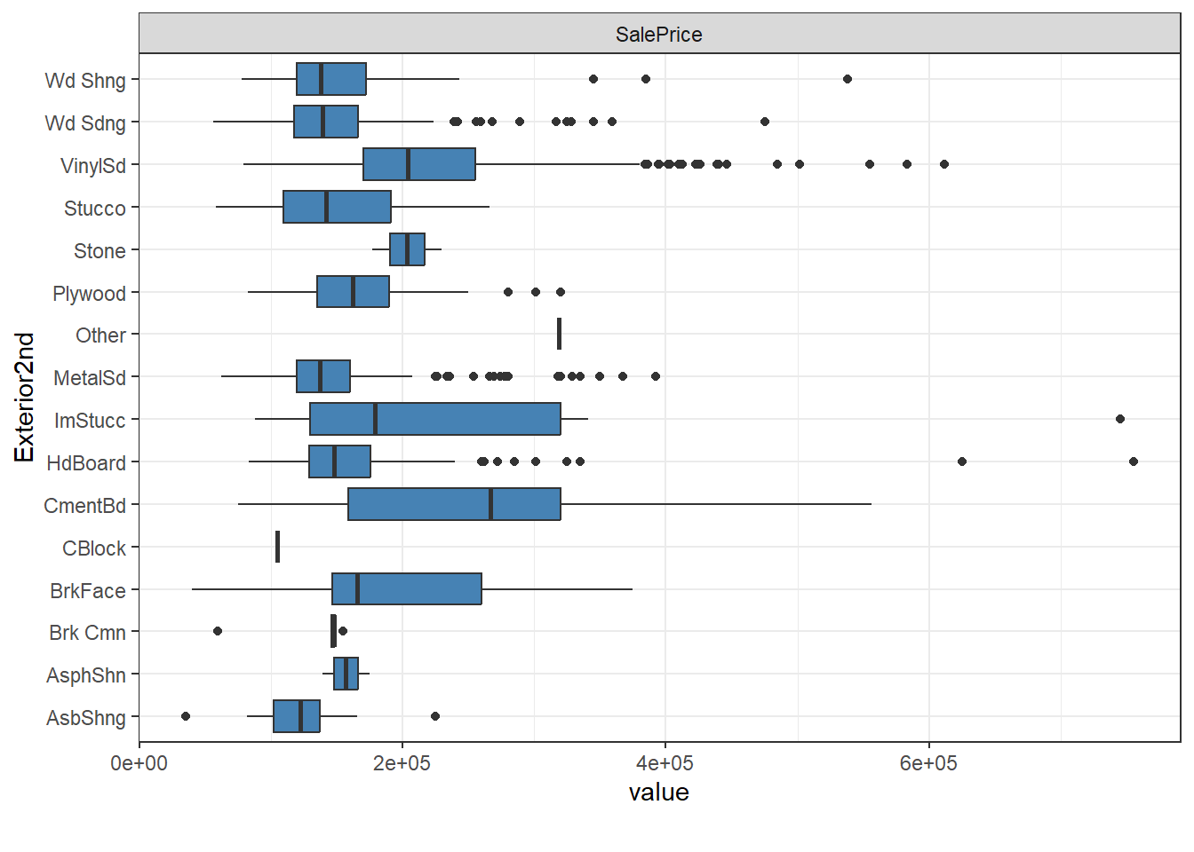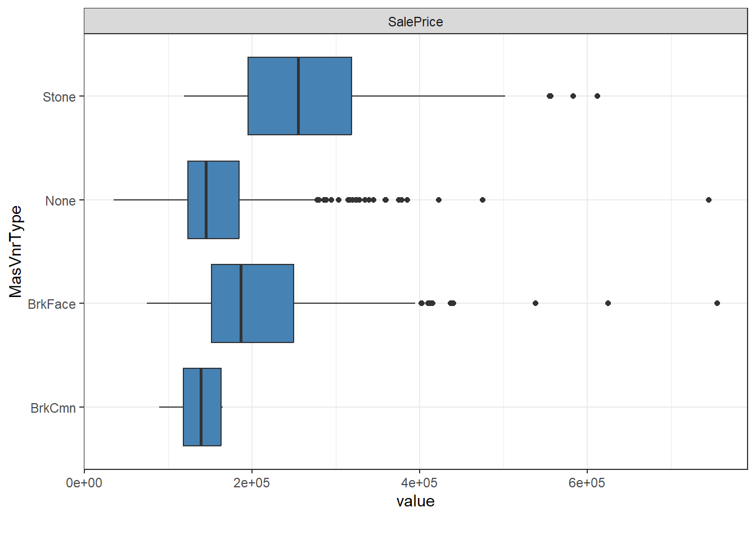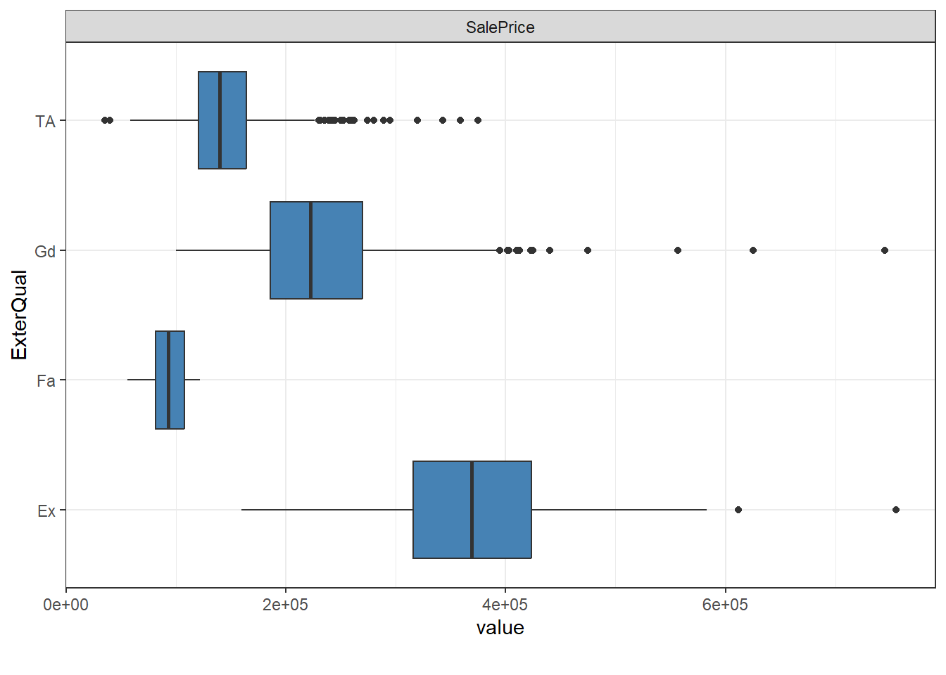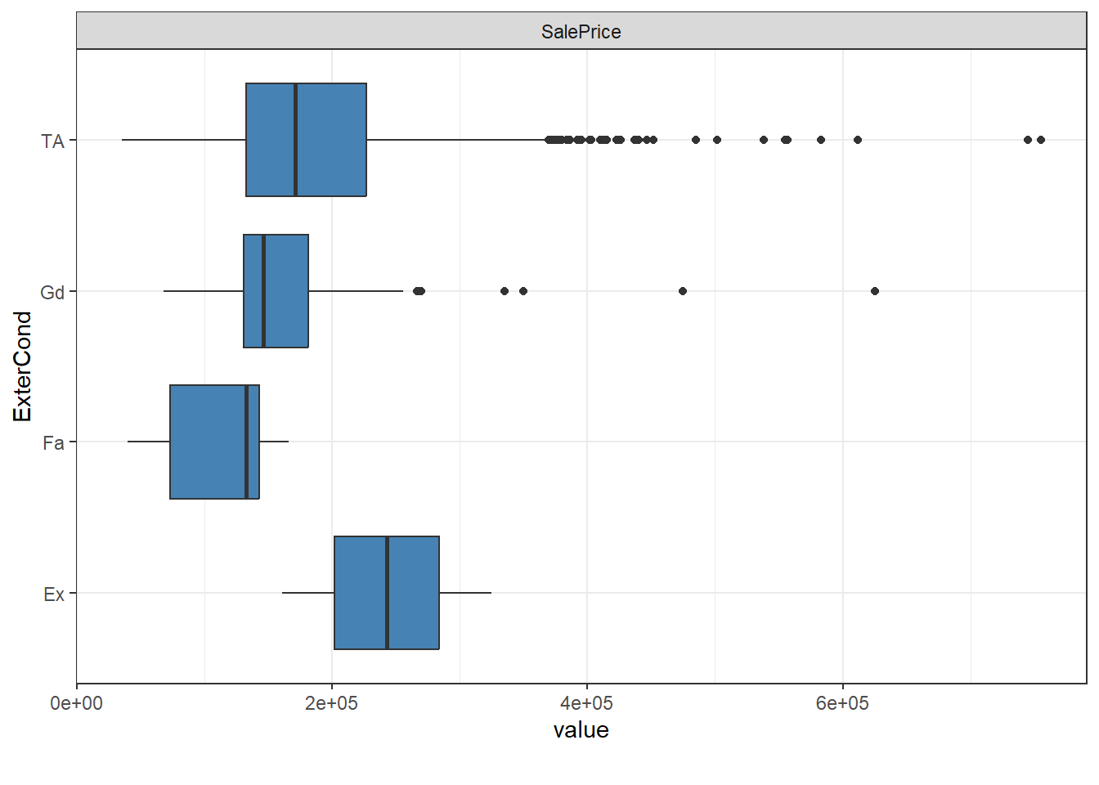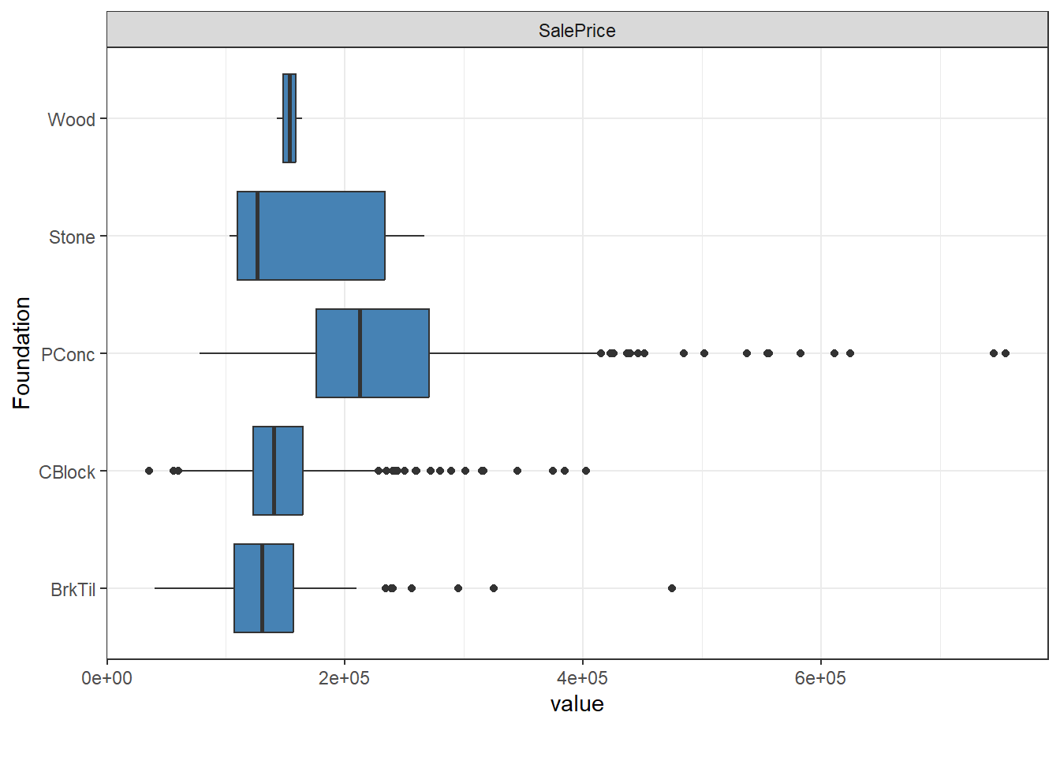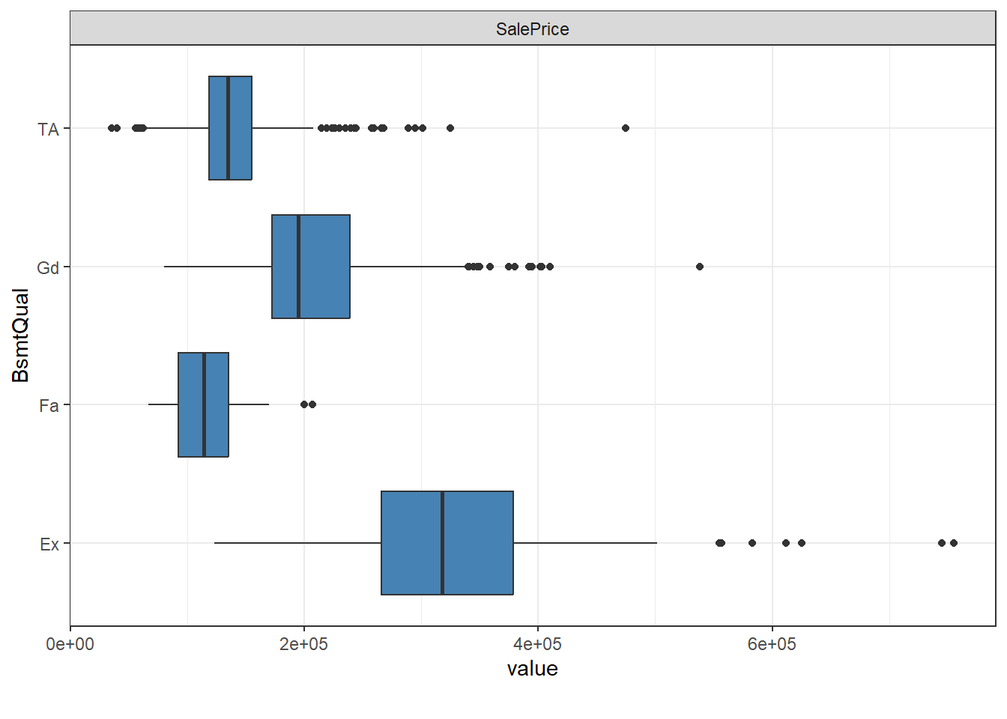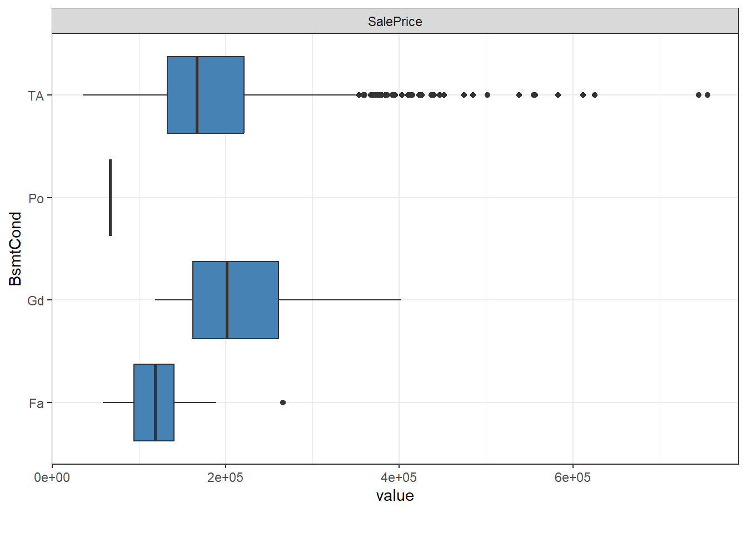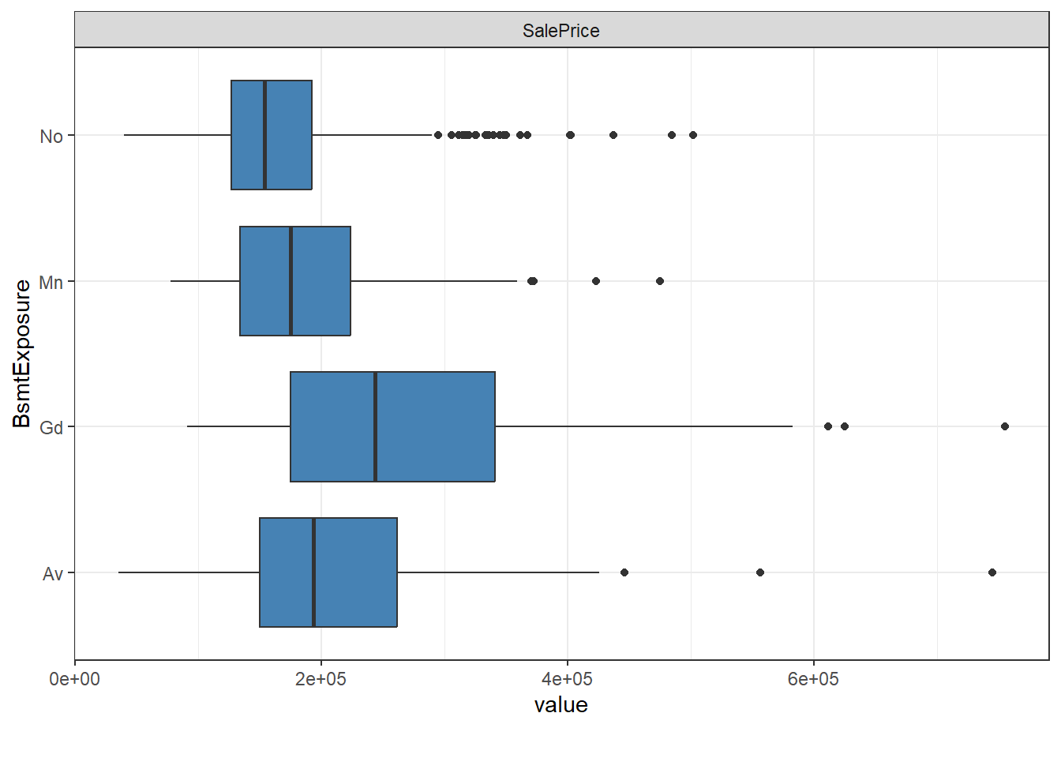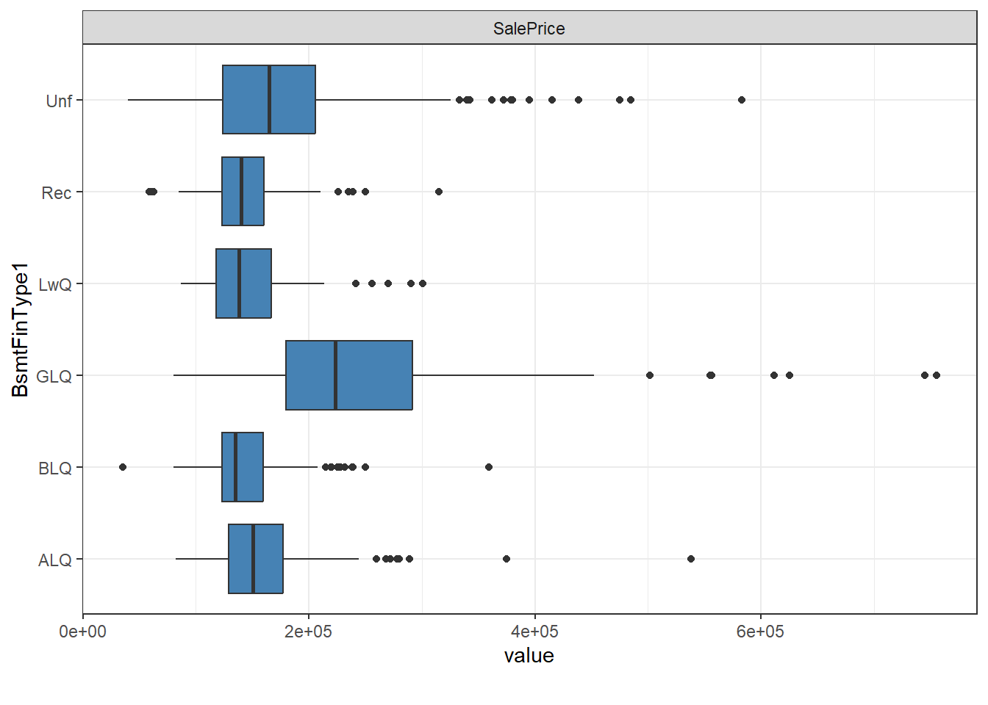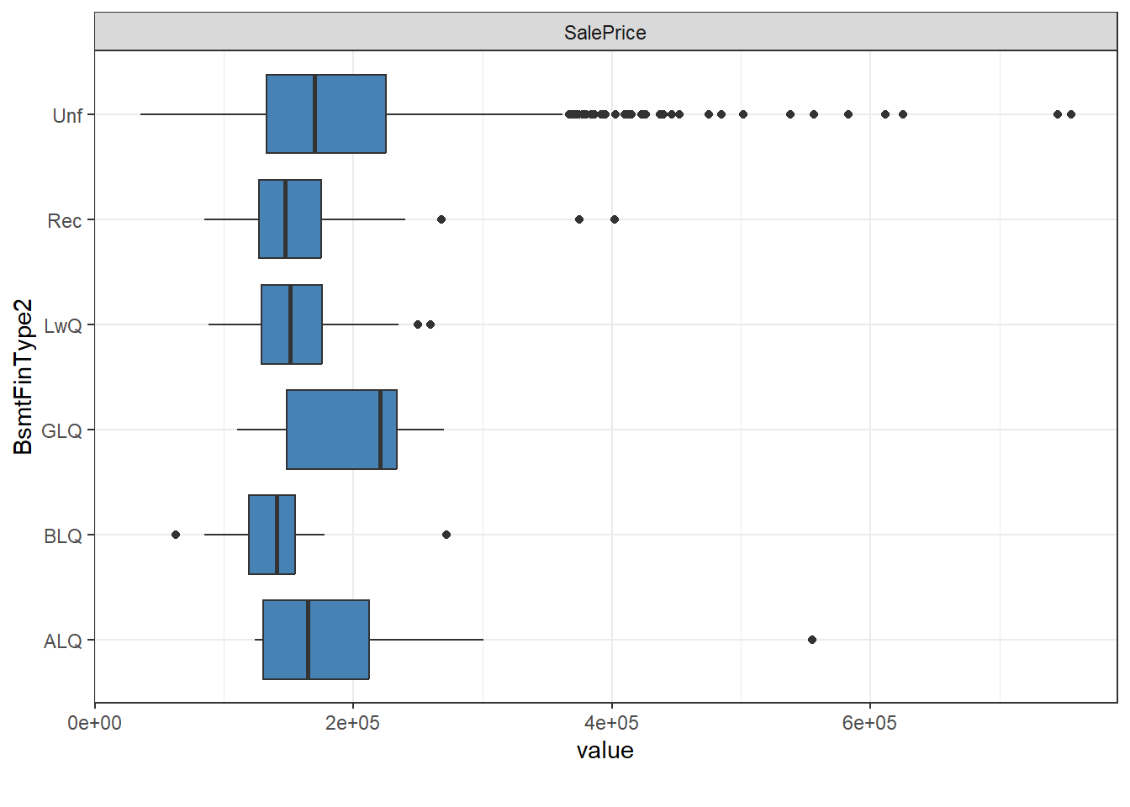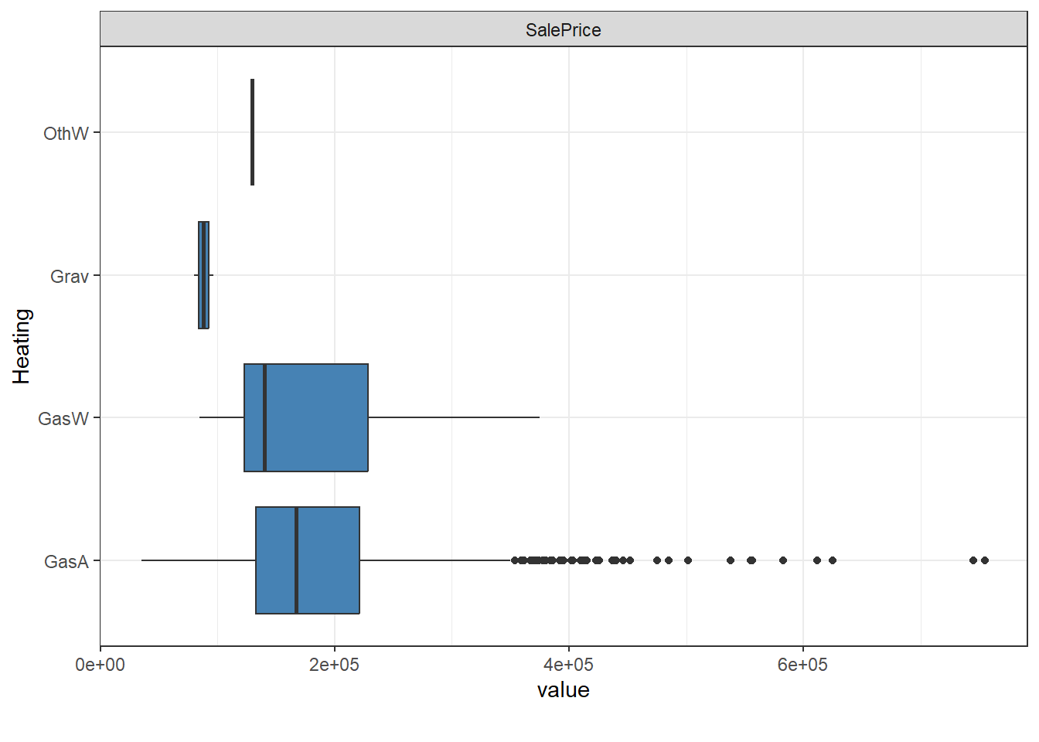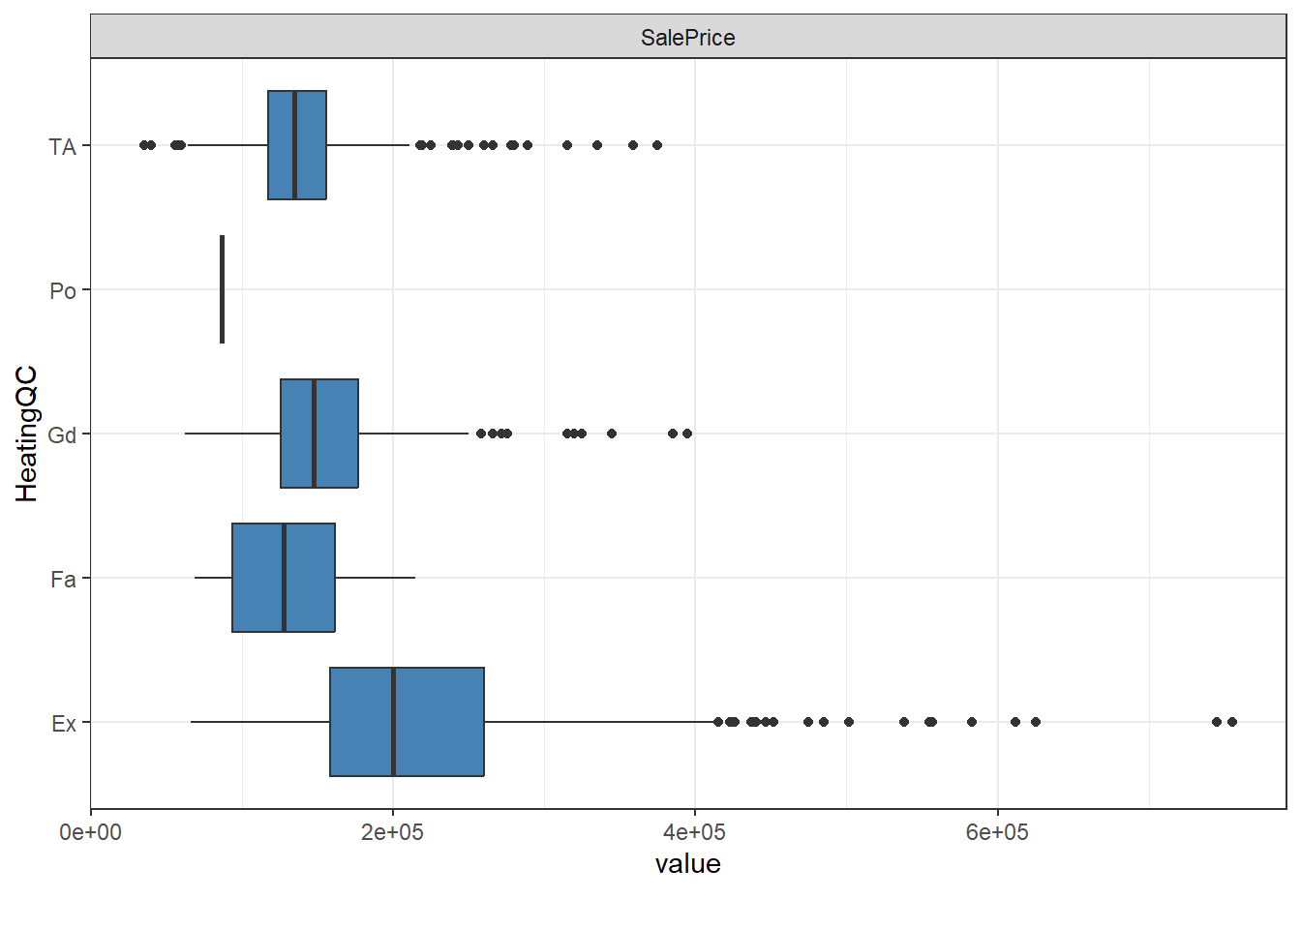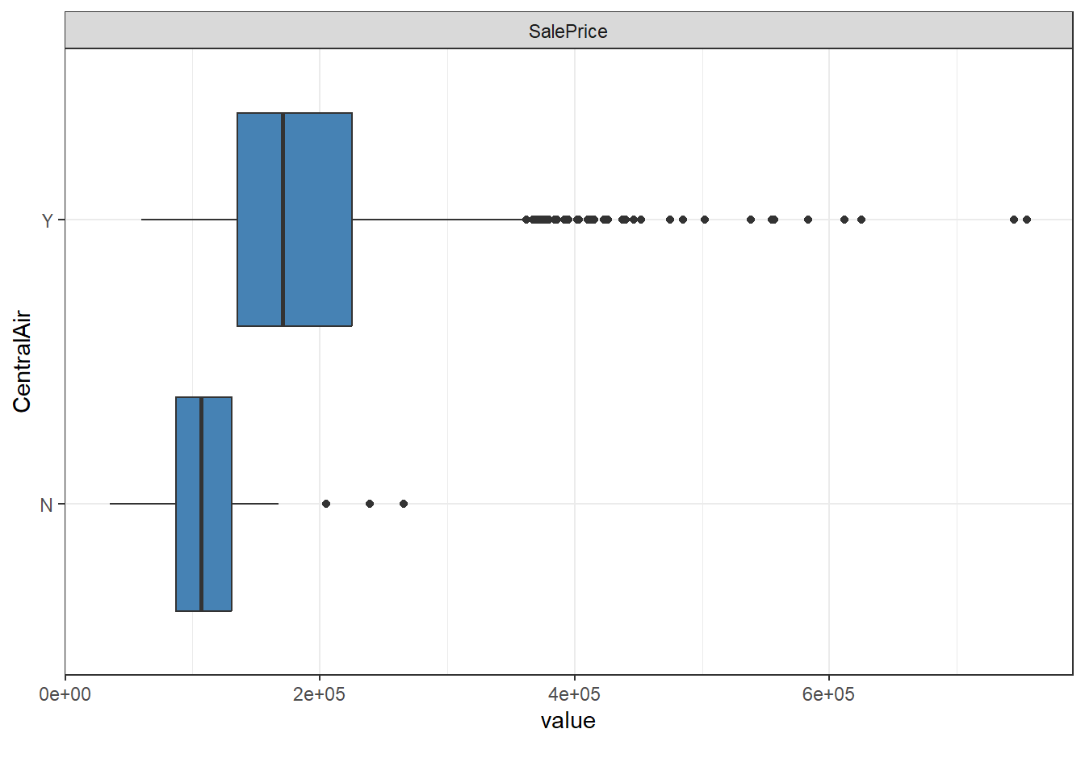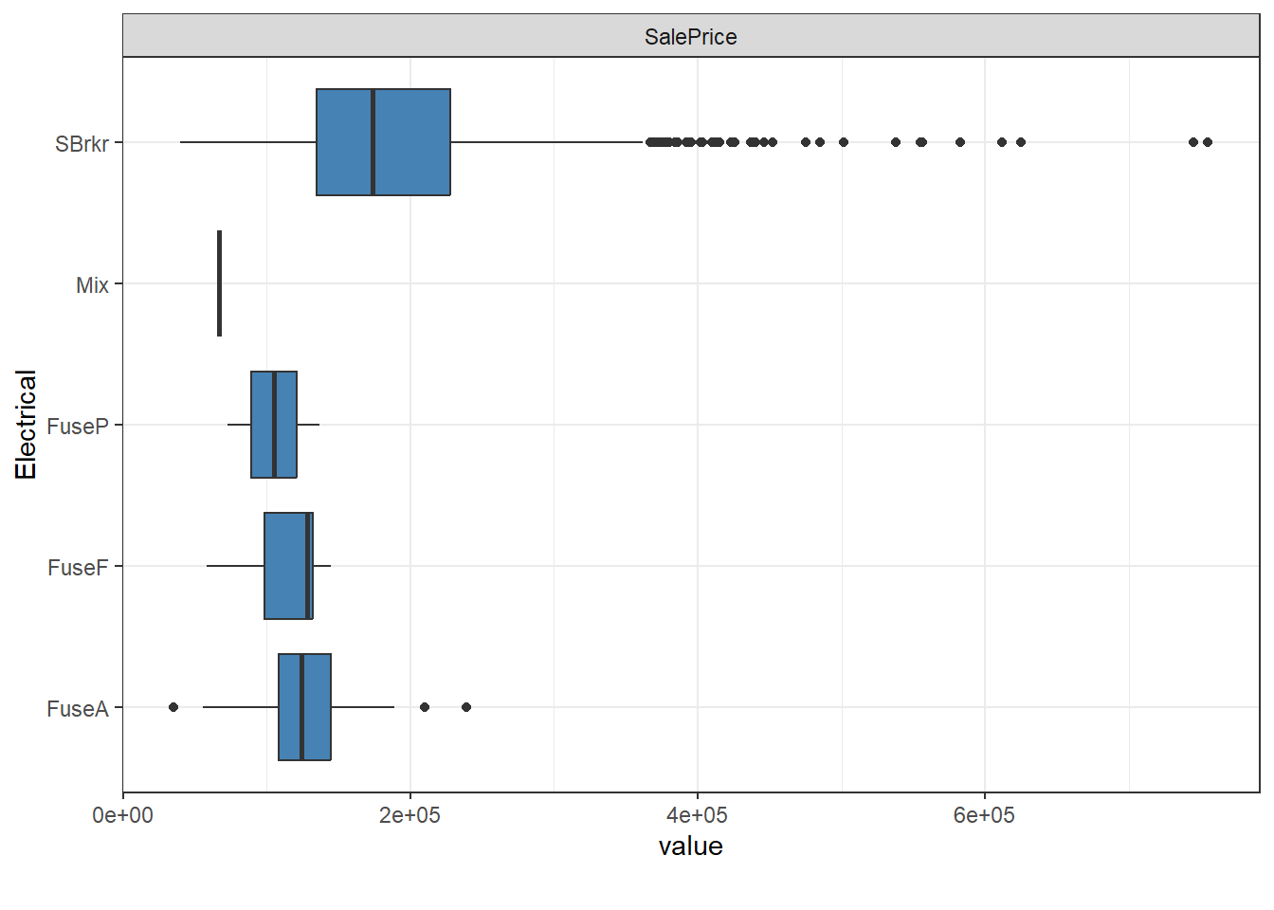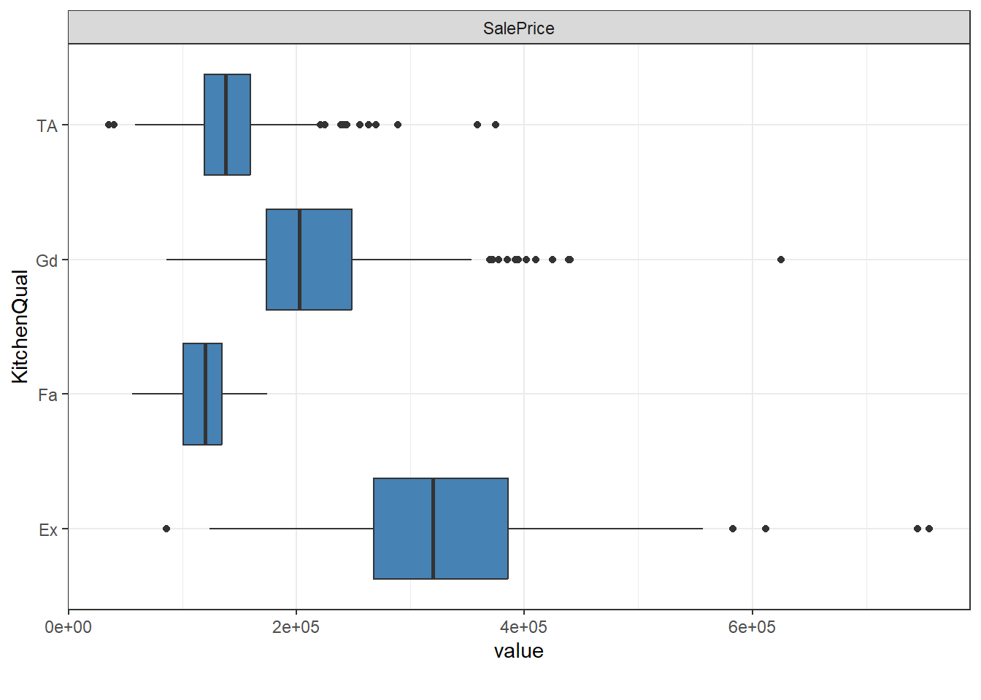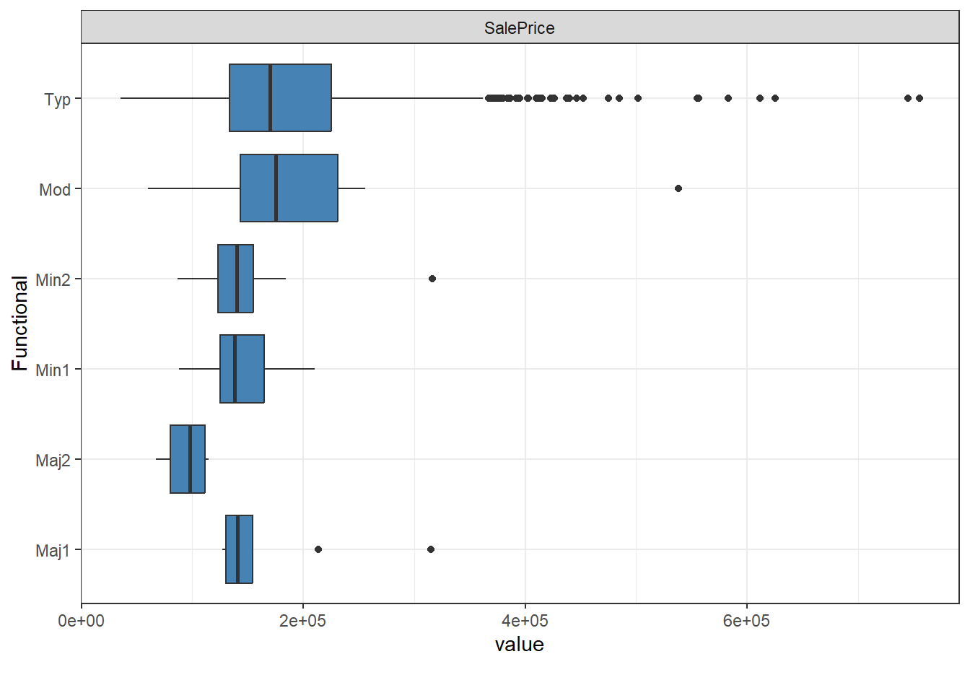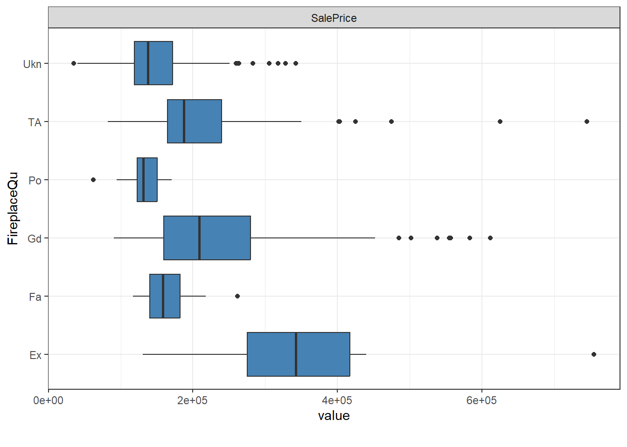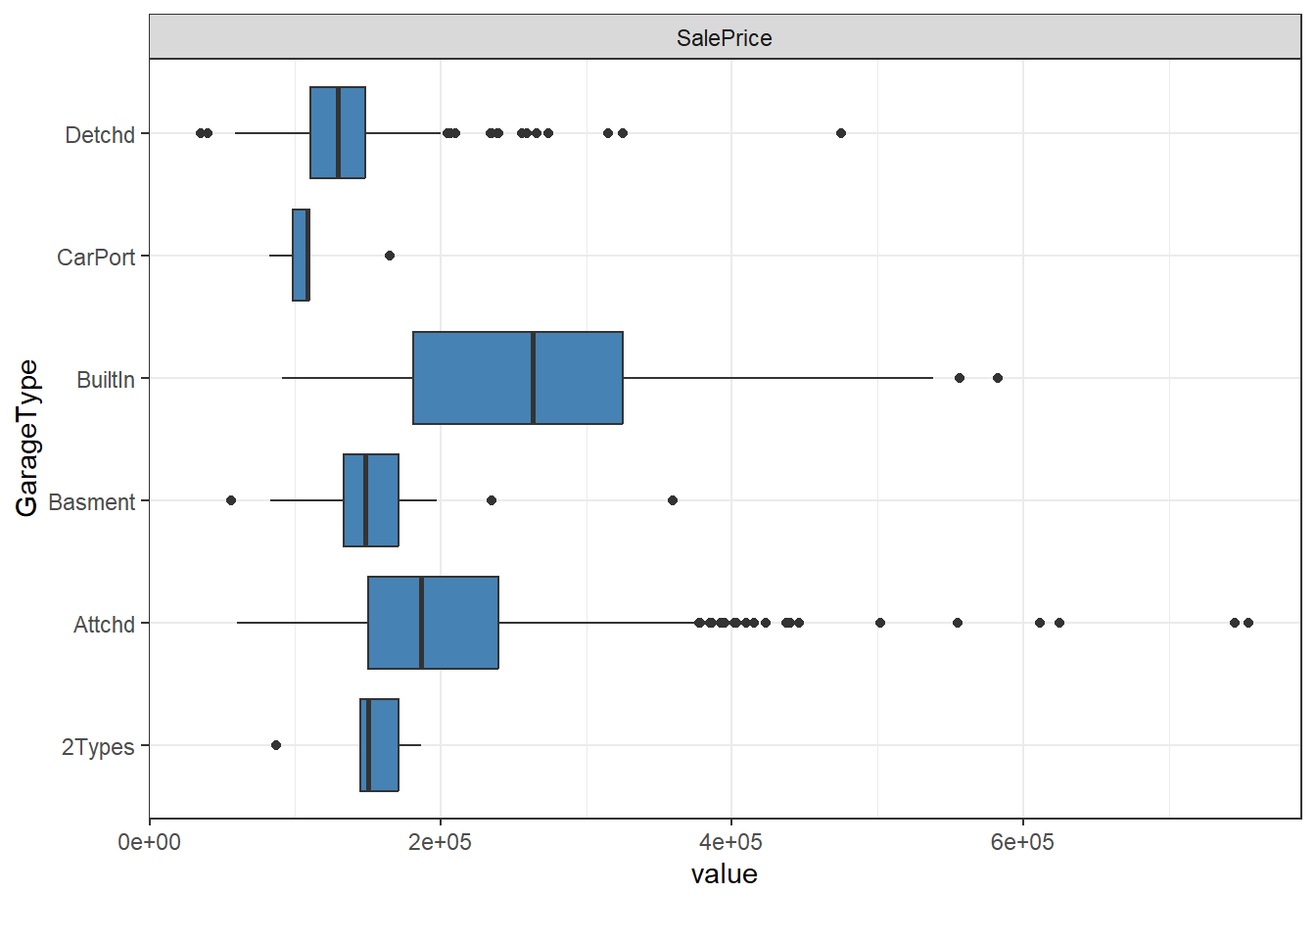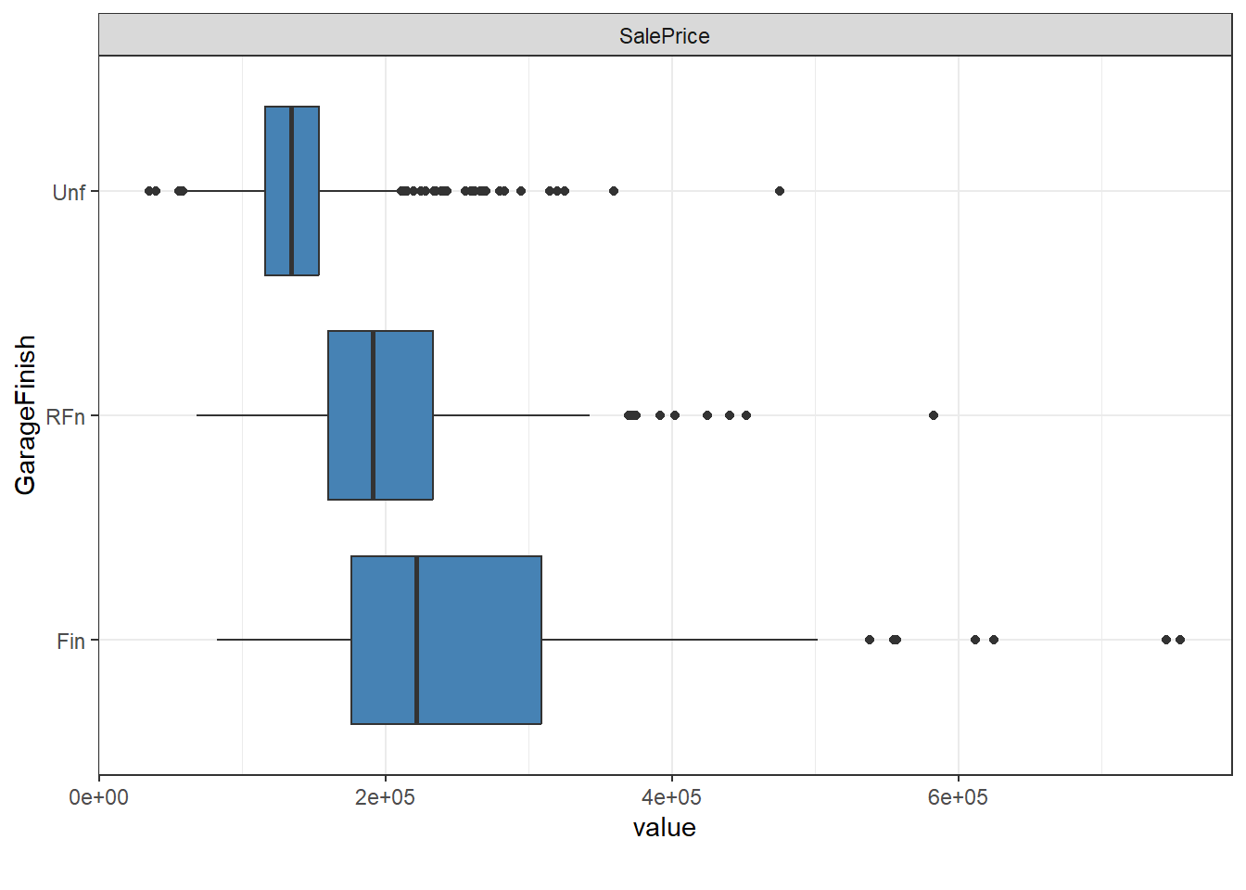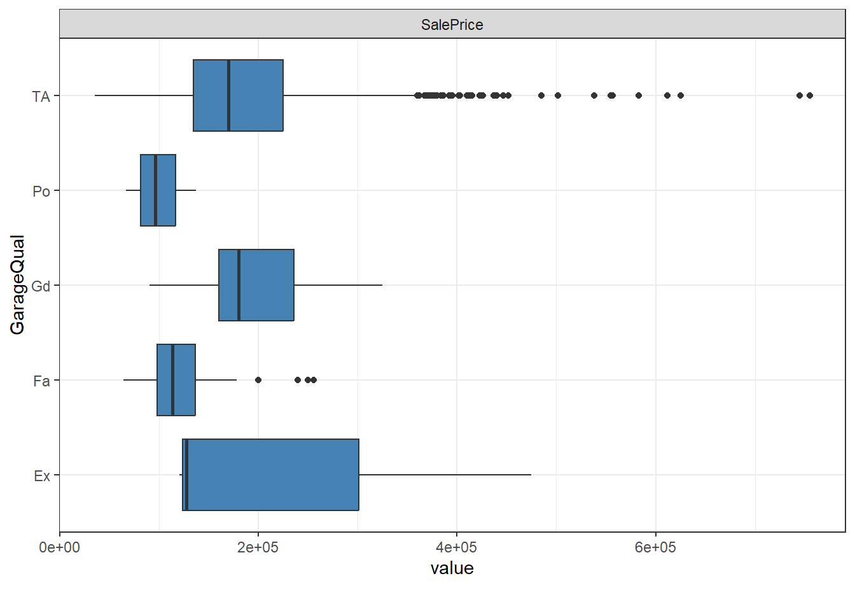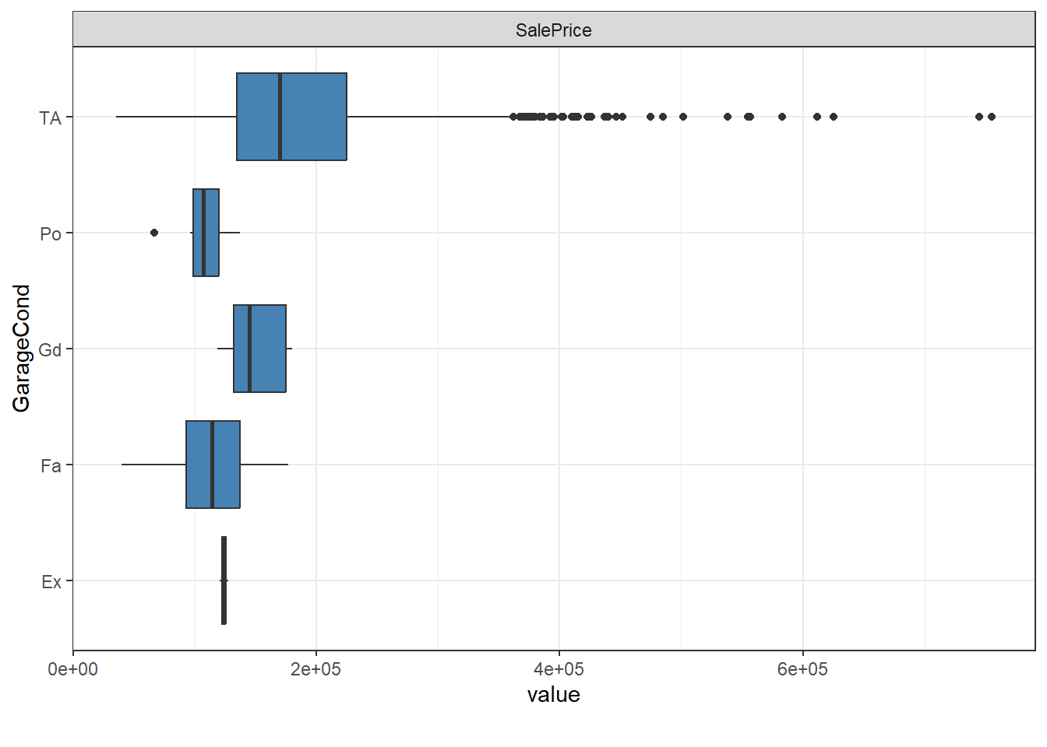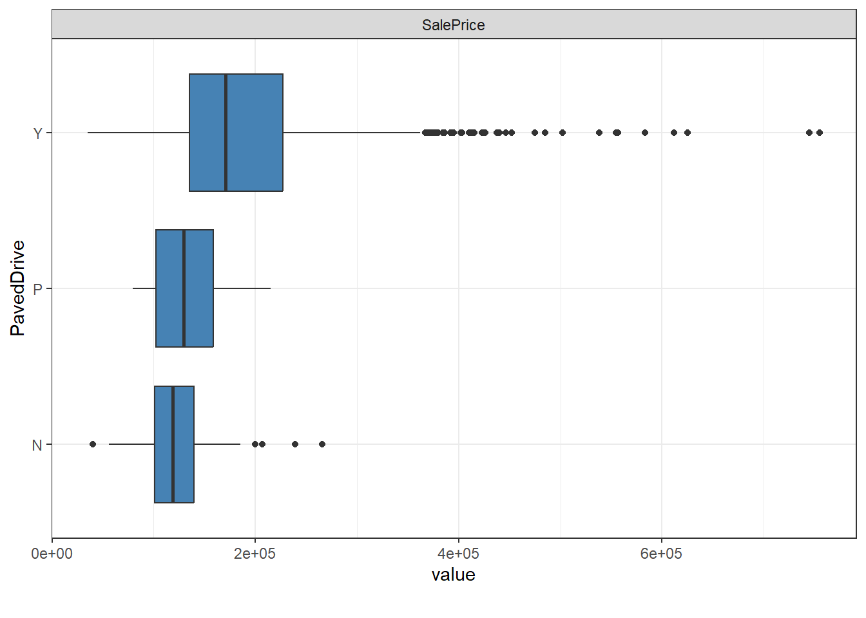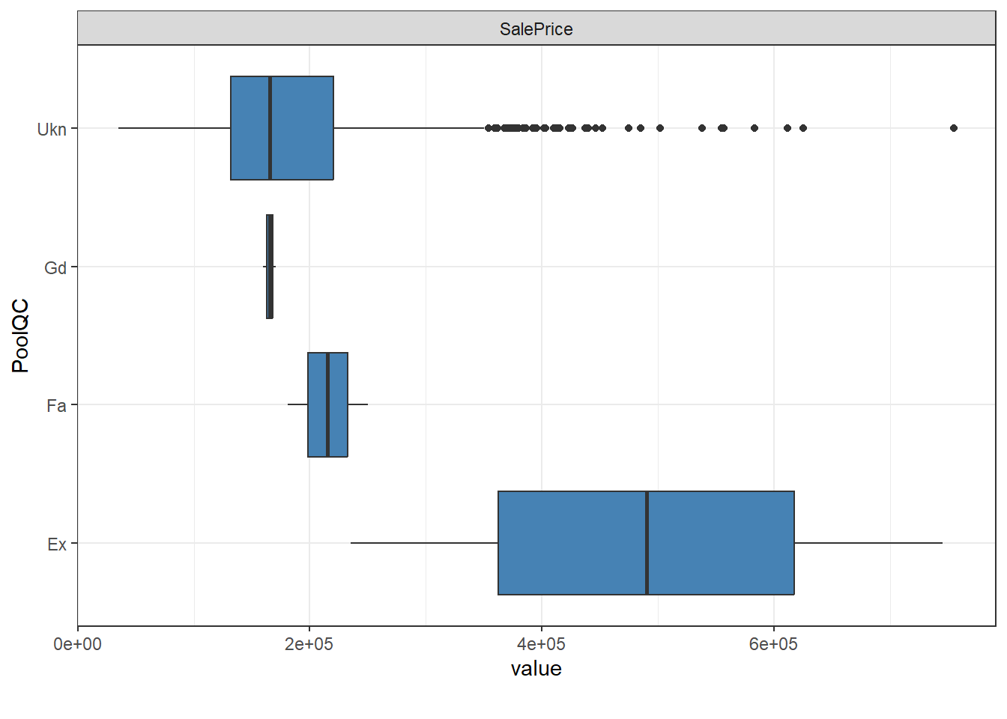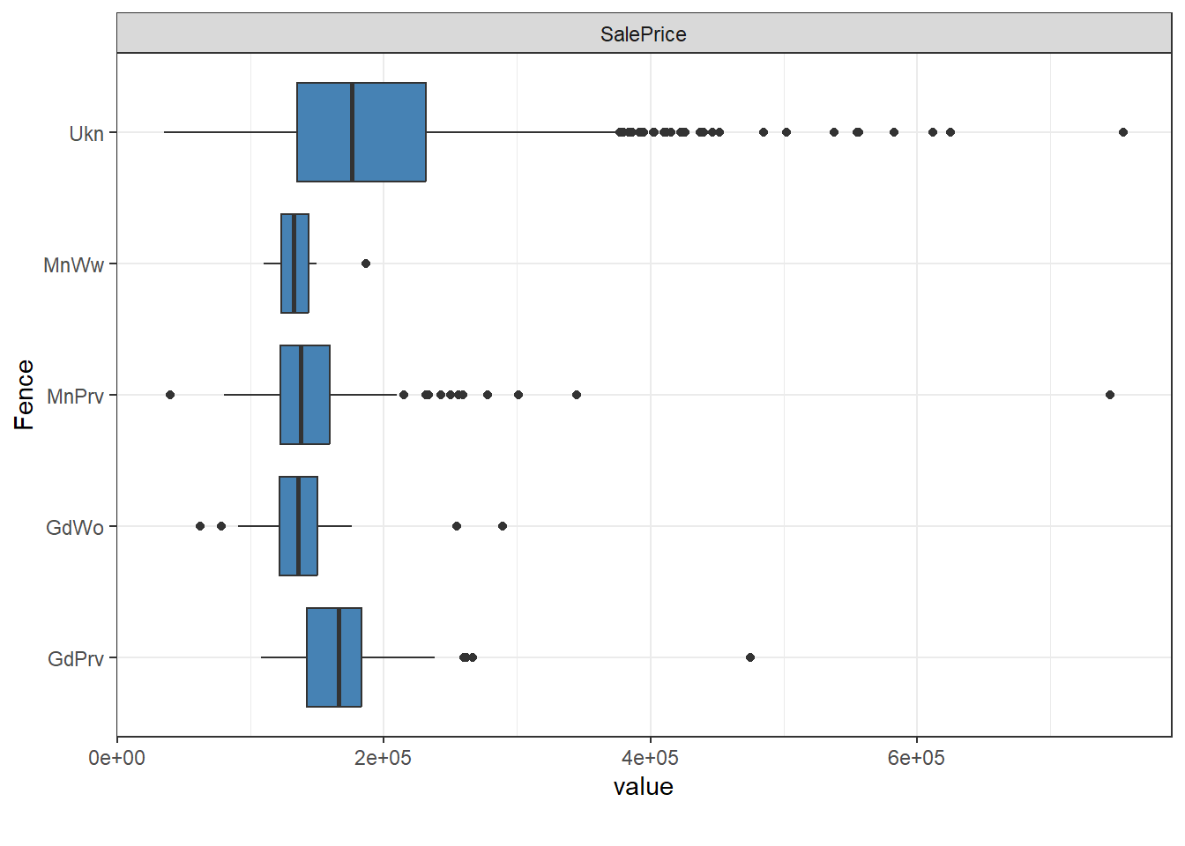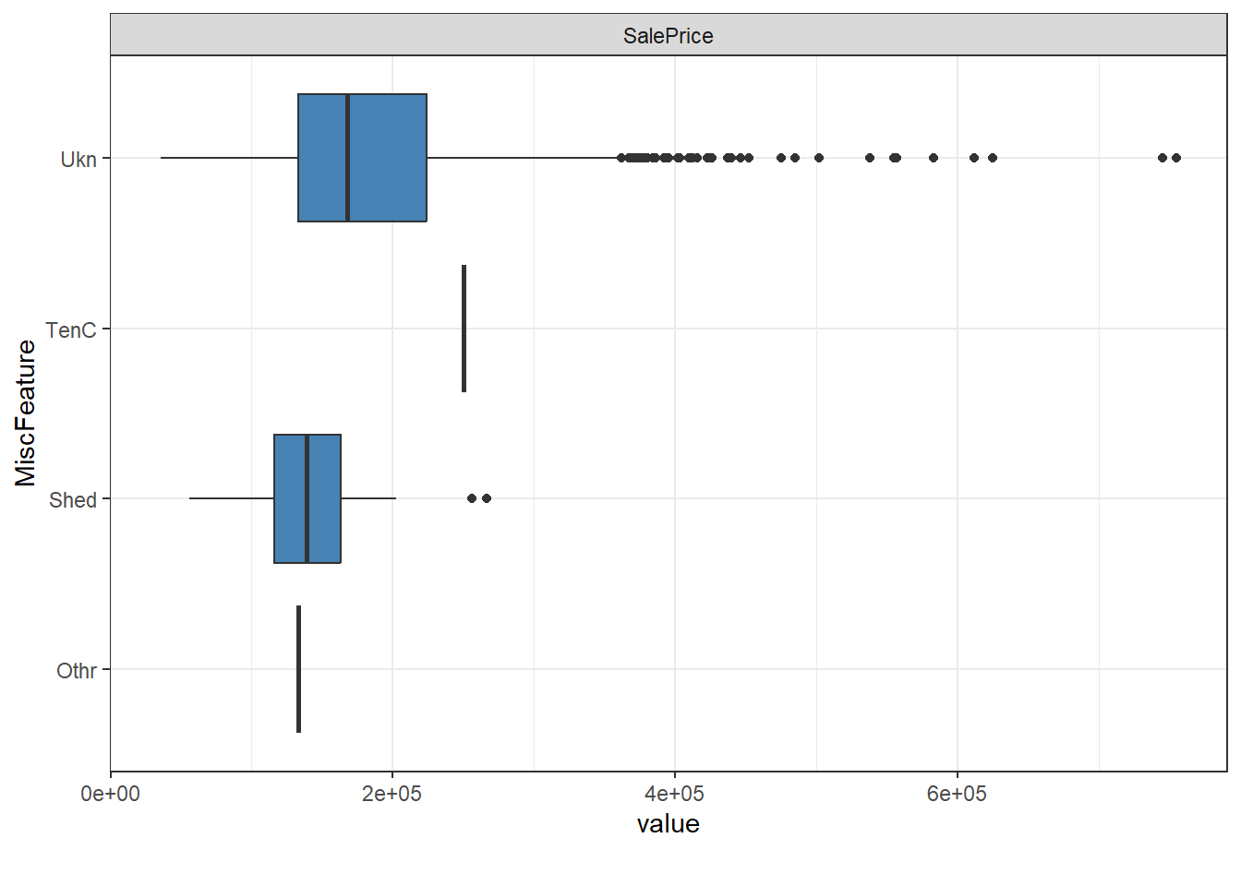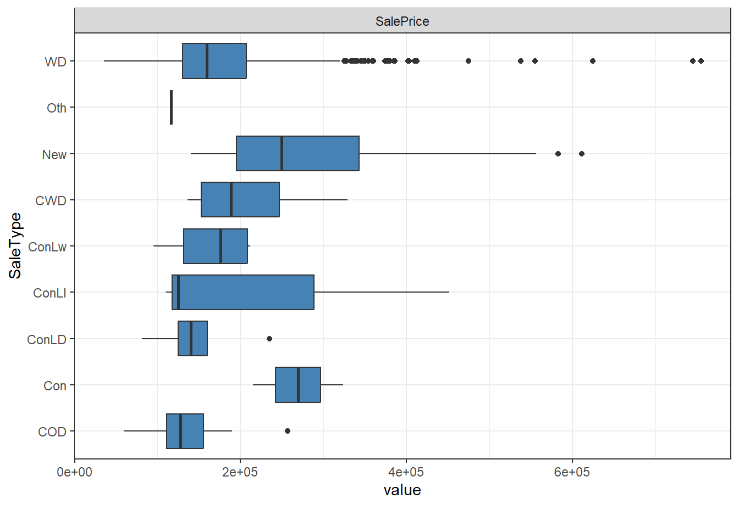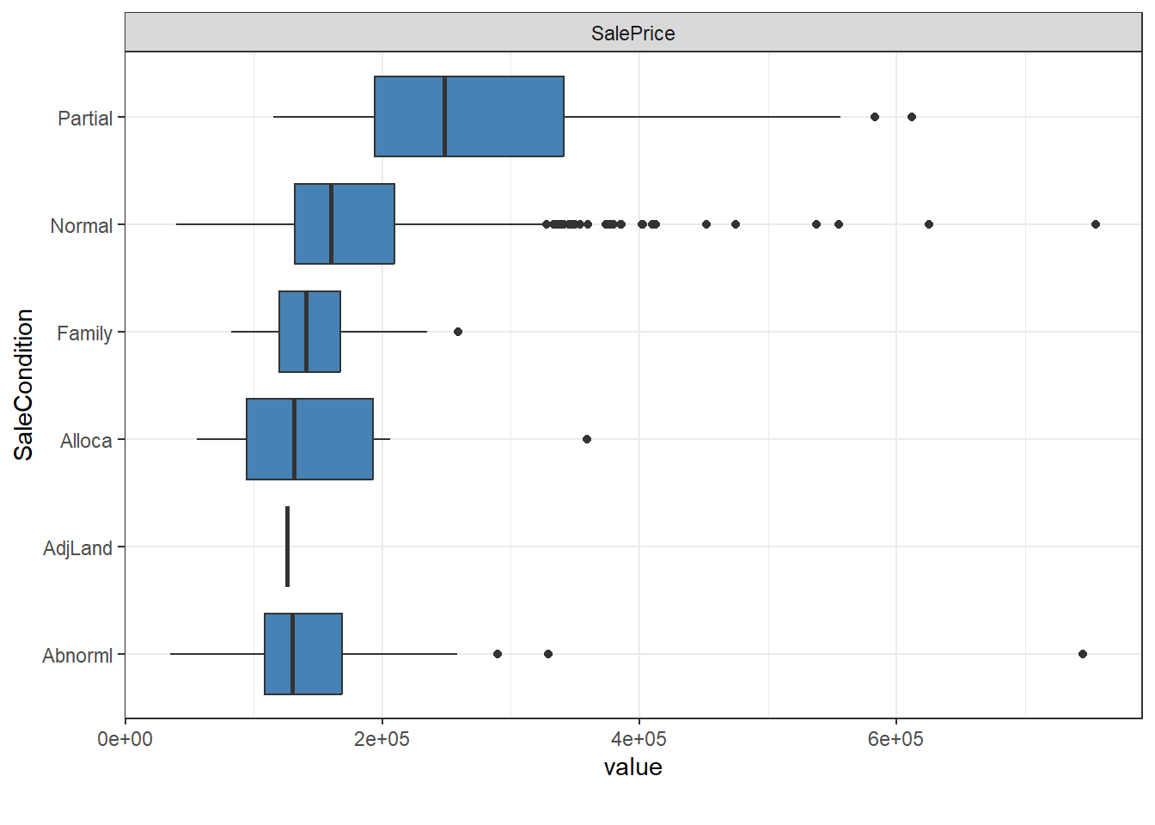

#Credit: “Gerry Alfa Dito”